**The British College**

**KATHMANDU**

**Coursework Submission Coversheet**(individual coursework only)

**Faculty of Arts, Environment and Technology LBU Student Id:**

77190010

**For checking by the student:**

Please ensure all information is complete and correct and attach this form securely to the front of your work before posting it in a coursework collection box.

Award name: Bsc (Hons) Computing

Module code: 15781

Module name: Advance Database System (ADS)

Module run: 2019_2020

Coursework title: Datamart, Datastaging, ETL, Implementation and consederation

Due Date:

Module leader: (In LBU): Jackie Campbell, Sanela Lazarevski

Module tutor: (In TBC): Dibya Tara Shakya

**TURNITIN** Checked: YES NO ***(please circle)***

Submission date& time: Date: 01/17/2020 Time: 12pm

**Total Word Count: 2391 Total Number of Pages (including this front sheet):67**

**In submitting this form with your assignment, you make the following declaration:**  
I declare, that the coursework submitted is my own work and has not (either in whole or part) been submitted towards the award of any other qualification either at LBU or elsewhere. I have fully attributed/referenced all sources of information used during the completion of my assignment, and I am aware that failure to do so constitutes an assessment offence.

Signed: Date: 01/17/2020

**You are strongly advised to retain a second copy of your work in case of any query about the assignment.**

**For completion by the faculty:**

**This mark is provisional and subject to moderation and approval by the relevant examining board**

**Teacher's Feedback**

**Teacher's Signature: __________________________________ Date: _________________**

Contents

Task 1: Extract, Transform and Load (ETL) script to populate the Star Schema (DM) with data 7

Extraction 7

Transformation 7

Loading 7

Extraction 8

Staging table 8

Trigger Creation for staging tables 10

Data Merging 12

Bad data tables 14

Bad triggers 16

Good data tables 18

Creating good tables trigger 20

Transmission 22

Procedure creation for loading into bad data tables from staging table 22

Procedure creation for cleaning bad data and loading it into good data table 31

Transformation 36

Re cleaning 36

Trigger creation for re clean 38

Procedure creation for re clean tables 40

Loading 50

Procedure creation for loading Good table data into dim table 50

Fact table 58

**Task 2: Data Analysis/OLAP/Mining Investigation** 59

Excel Reports 59

Tableau report 62

Apex reports 65

Task 3: Considerations for the Data Mart. 68

Data Maintenance 68

Horizontal Partitioning 68

Vertical Partitioning 68

Functional Partitioning 69

Slow Changing Dimension (SCD) 69

Type 0 69

Type 1 69

Type 2 69

Type 3 70

Type 4 70

Type 6 70

## Task 1: Extract, Transform and Load (ETL) script to populate the Star Schema (DM) with data

### Extraction

**Data extraction is where data is analyzed and crawled through to retrieve relevant information from data sources (like a database) in a specific pattern. Further data processing is done, which involves adding metadata and other data integration; another process in the data workflow. The majority of data extraction comes from unstructured data sources and different data formats. This unstructured data can be in any form, such as tables, indexes, and analytics.**

## Transformation

**Data transformation is the process of converting data from one format or structure into another format or structure. Data transformation is critical to activities such as data integration and data management. Data transformation can include a range of activities: you might convert data types, cleanse data by removing nulls or duplicate data, enrich the data, or perform aggregations, depending on the needs of your project.**

## Loading

**The load phase loads the data into the end target, which can be any data store including a simple delimited flat file or a data warehouse. Some data warehouses may overwrite existing information with cumulative information; updating extracted data is frequently done on a daily, weekly, or monthly basis. Other data warehouses (or even other parts of the same data warehouse) may add new data in a historical form at regular intervals — for example, hourly. To understand this, consider a data warehouse that is required to maintain sales records of the last year. This data warehouse overwrites any data older than a year with newer data. However, the entry of data for any one year window is made in a historical manner.**

## Extraction

## Staging table

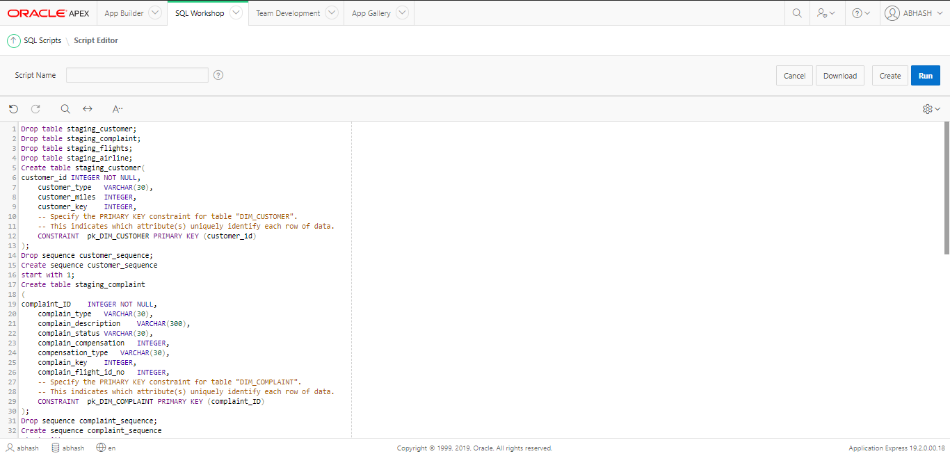

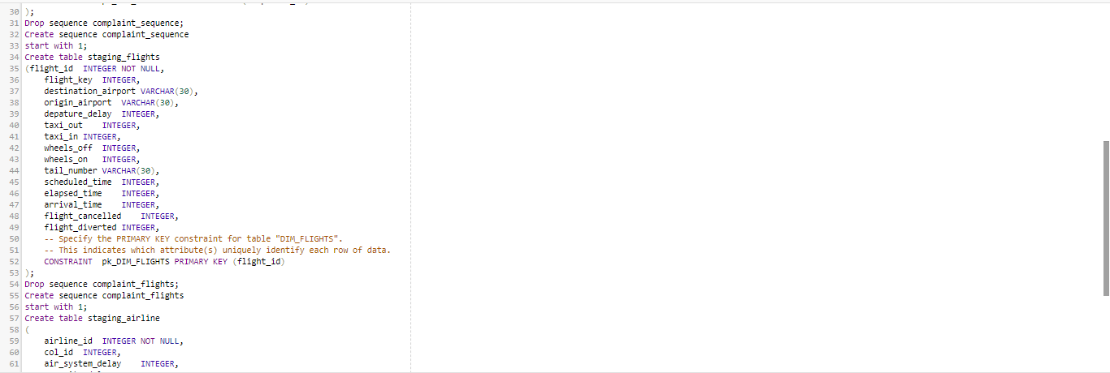

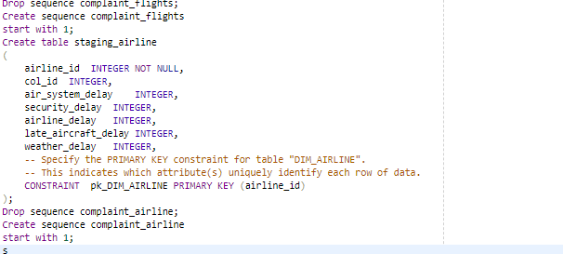

**Above screenshot shows Creating staging tables staging_customer,staging_flights,staging_airline,and staging_complaint and its sequeneces**

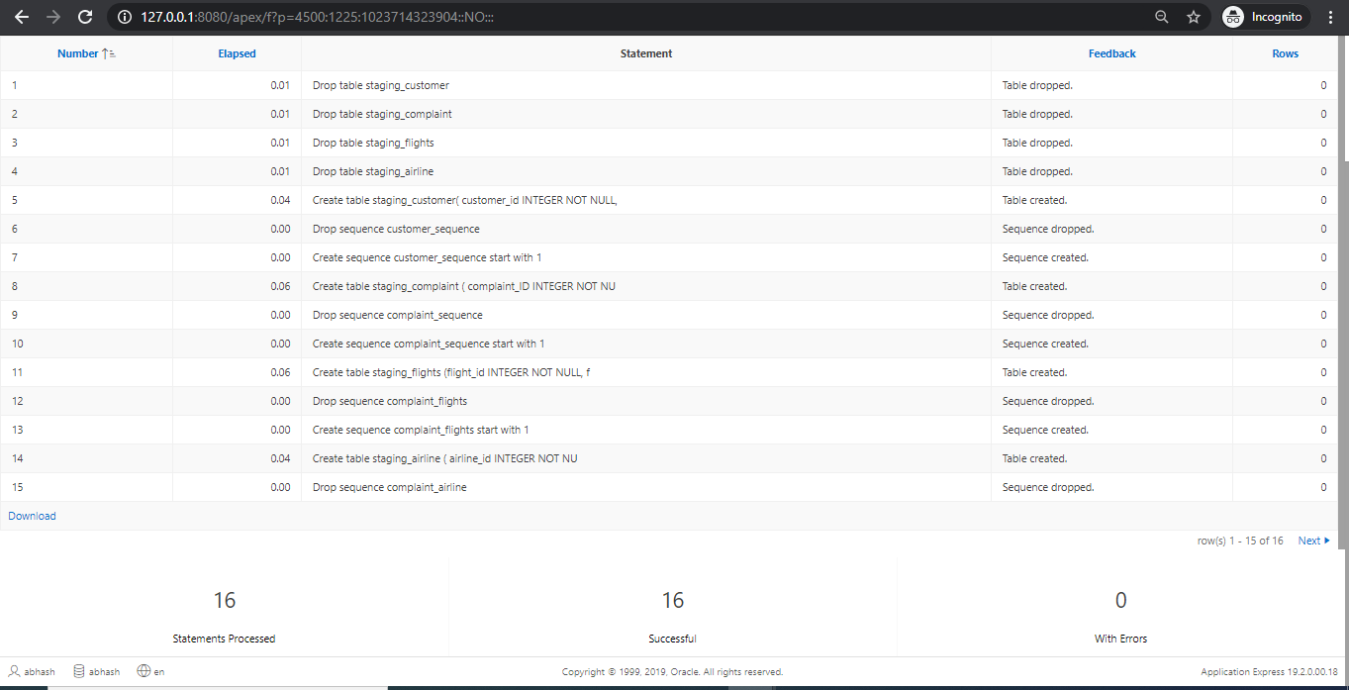

**Above screenshot shows Creating staging table sucessfully and sequence sucessfully**

## Trigger Creation for staging tables

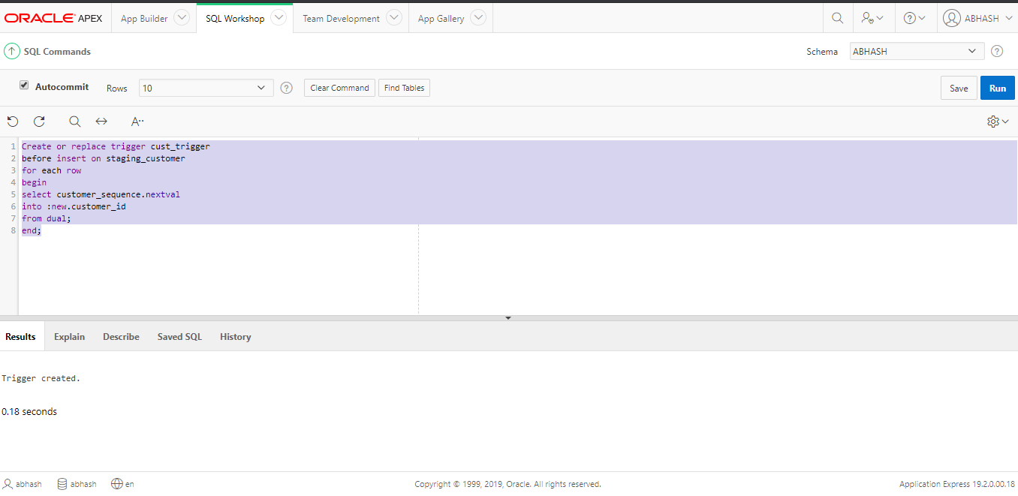

**Above screenshot shows Creating trigger for staging table staging_customer**

**Above screenshot shows 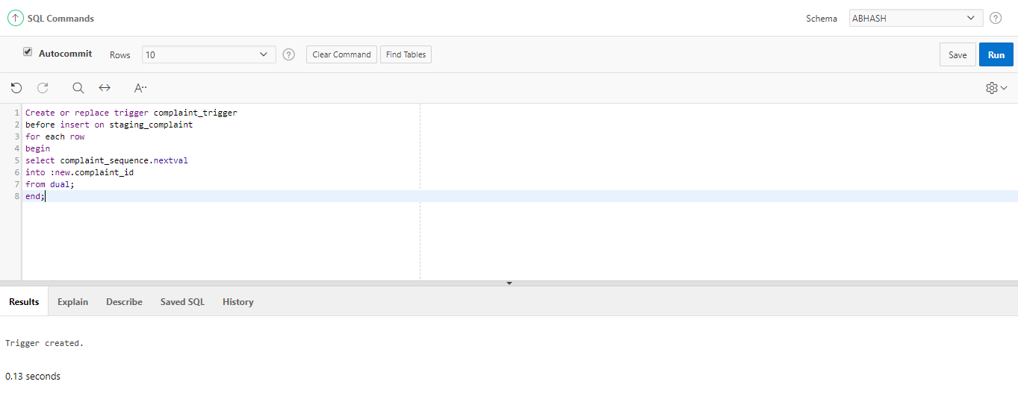Creating trigger for staging table staging_complaint**

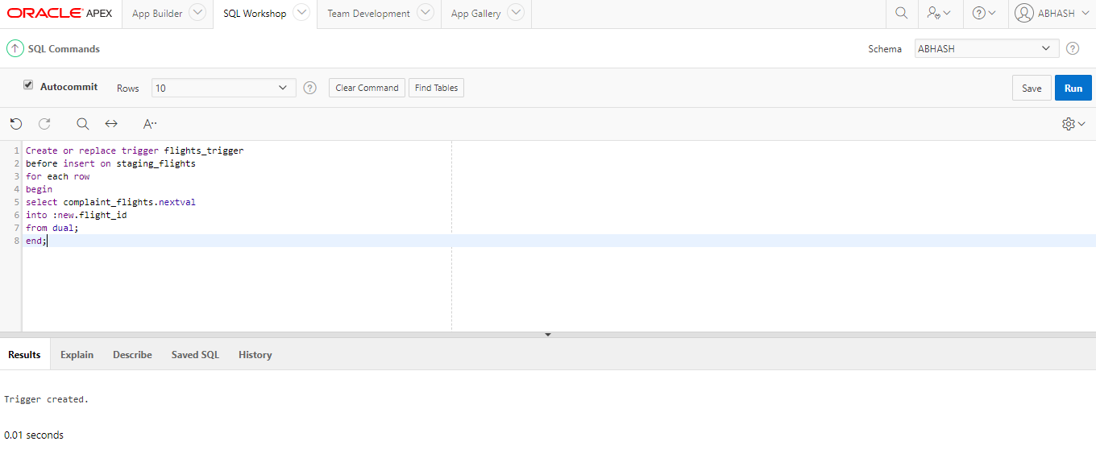

**Above screenshot shows Creating trigger for staging table staging _flights**

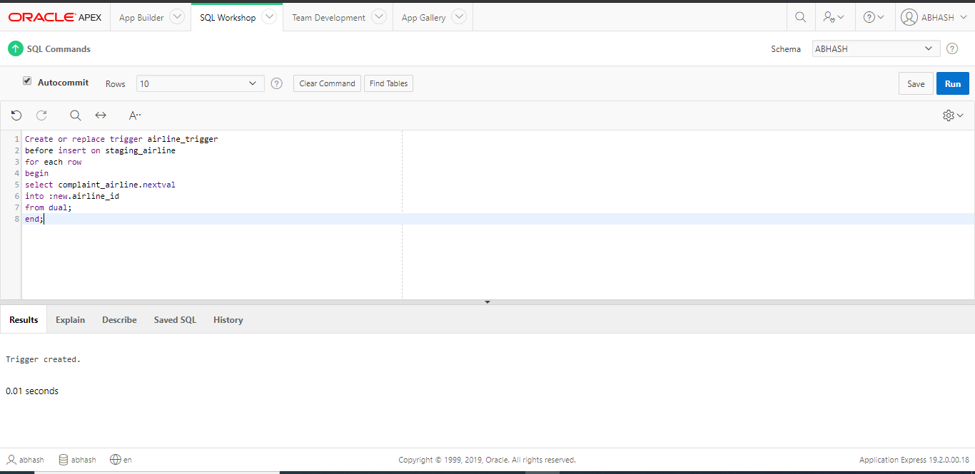

**Above screenshot shows Creating trigger for staging table staging_airline**

## Data Merging

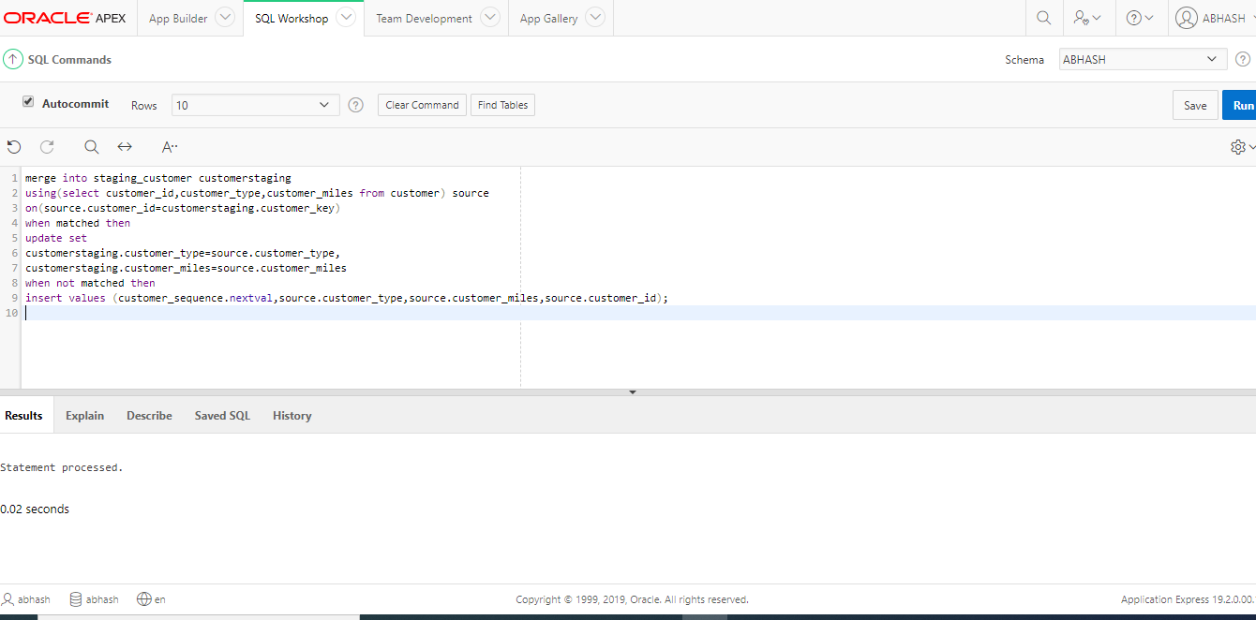

**Above screenshot shows Merging source table data ‘customer’ into staging table ‘staging_customer’**

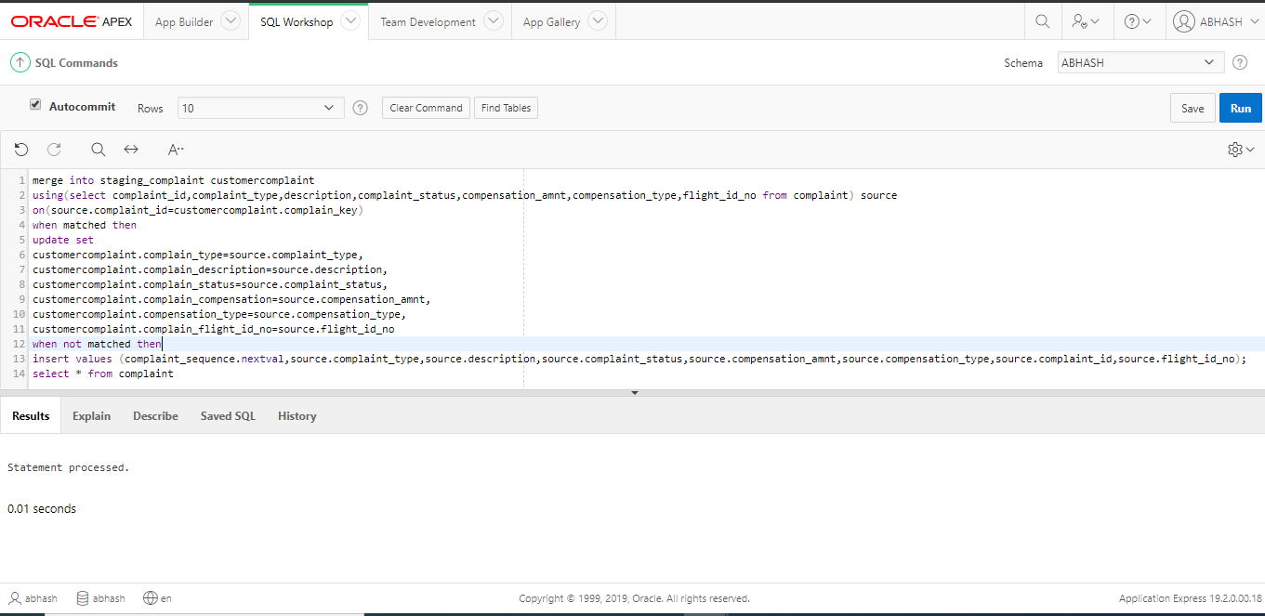

**Above screenshot shows Merging source table ‘complaint’ data into staging table ‘staging_complaint’**

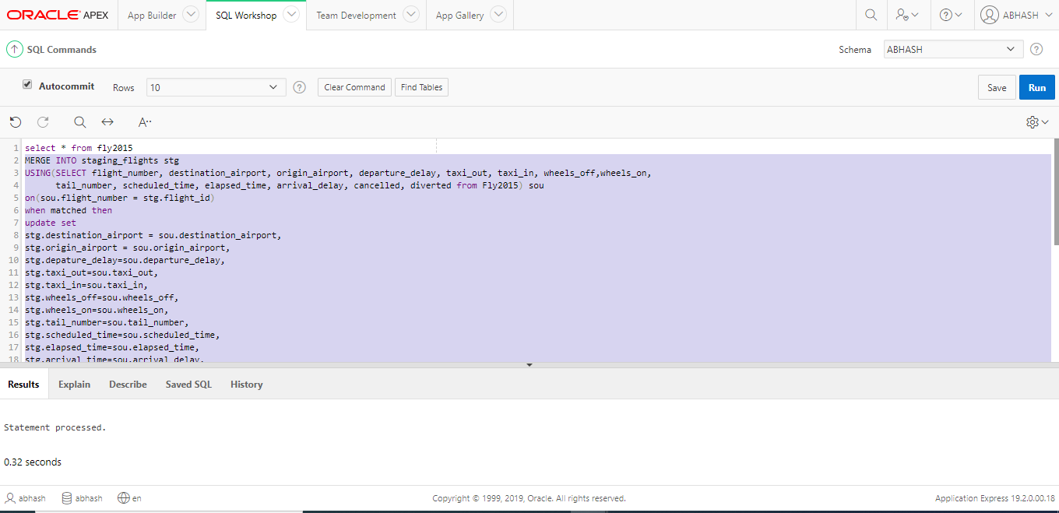

**Above screenshot shows Merging source table data ‘fly2015’ into staging table ‘staging_flights’**

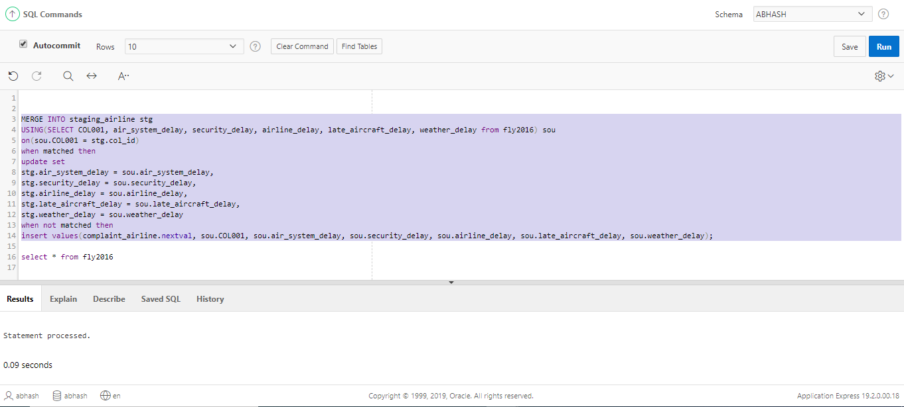

**Above screenshot shows Merging source table data ‘fly2016’ into staging table ‘staging_airline’**

## Bad data tables

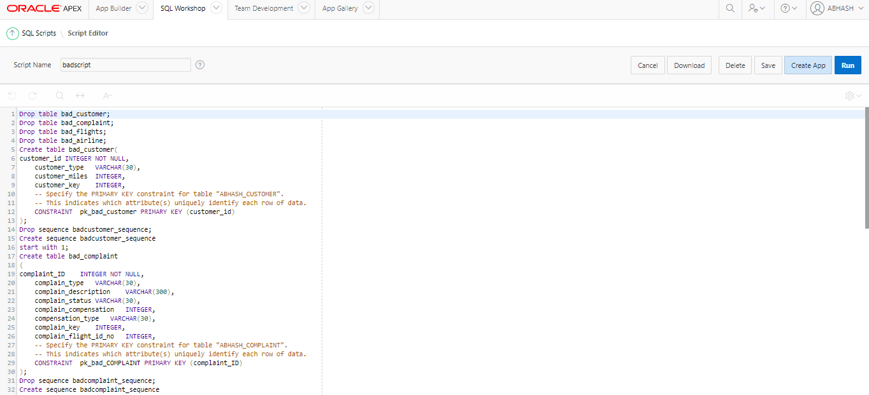

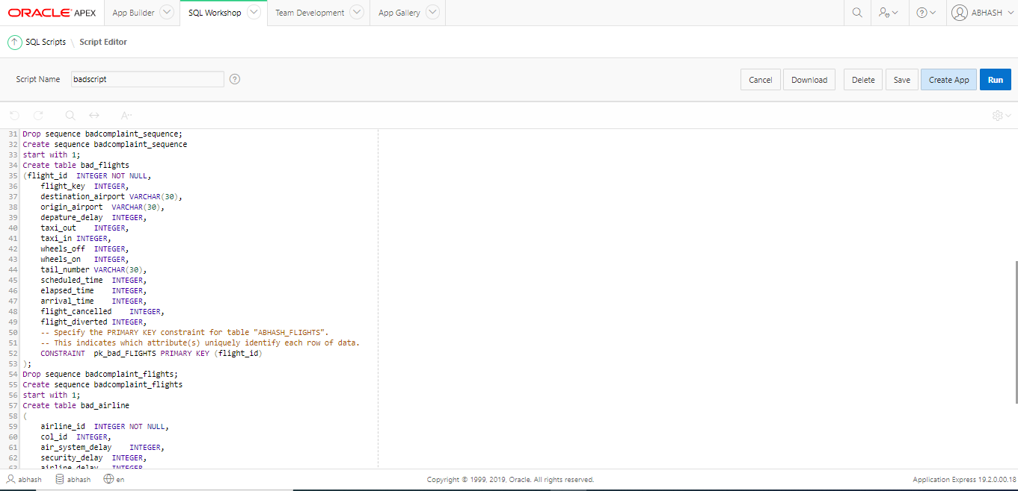

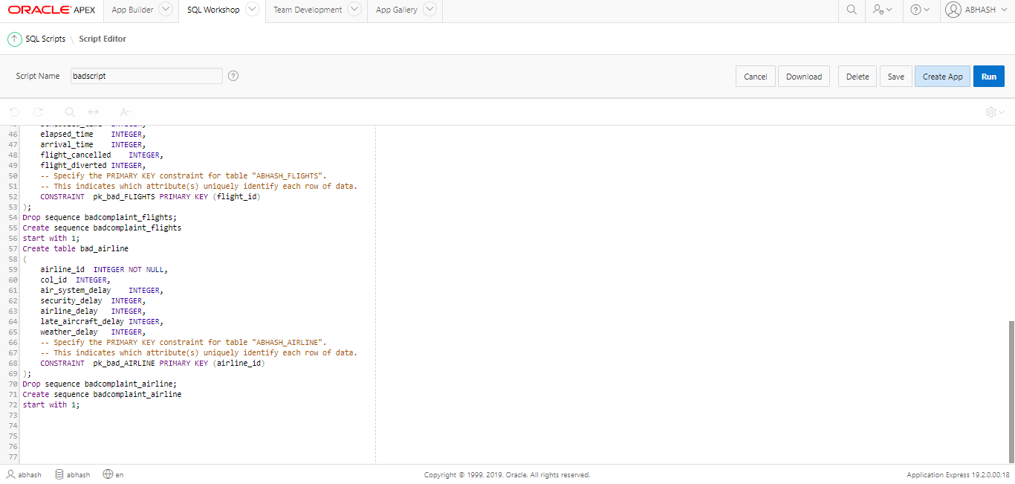

**Above screenshot shows Creating bad data table’s bad_customer, bad_complaint, bad airline, bad_flights and it sequences**

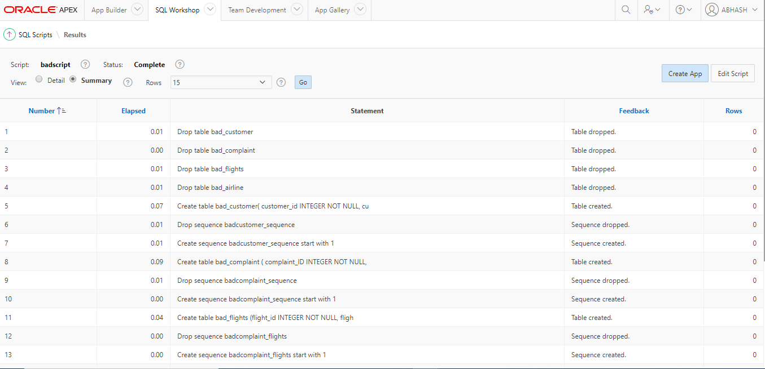

**Above screenshot shows Tables and sequences created successfully**

## Bad triggers

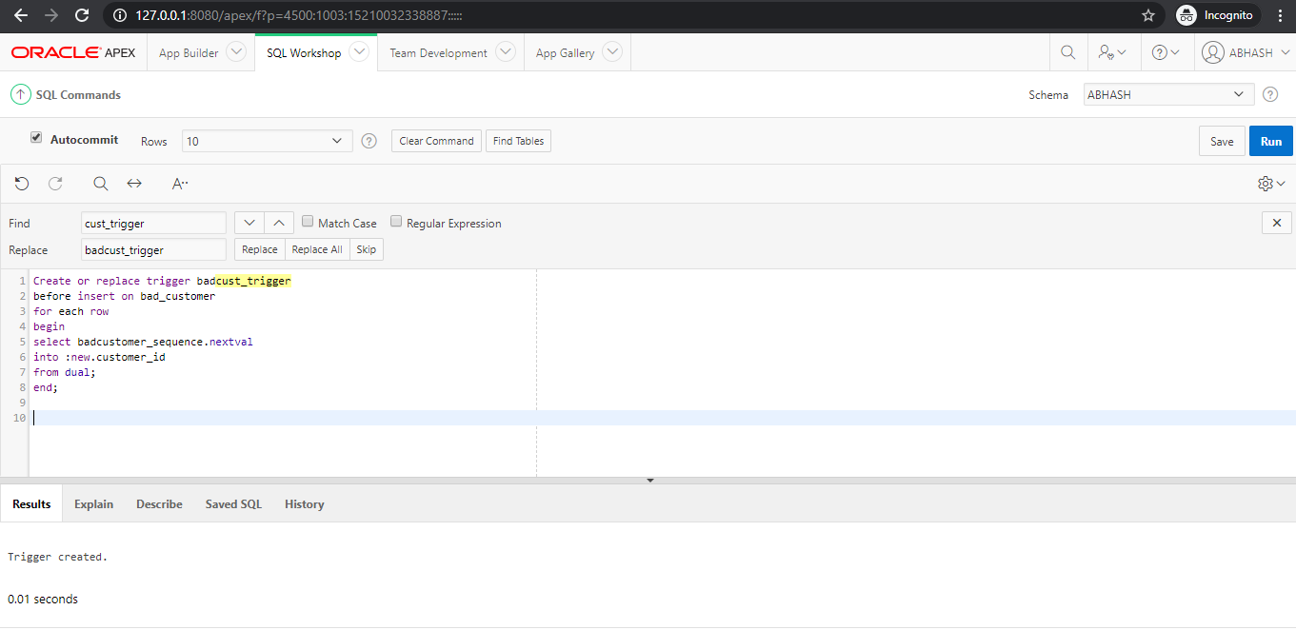

**Above screenshot shows Creating trigger for table bad_customer**

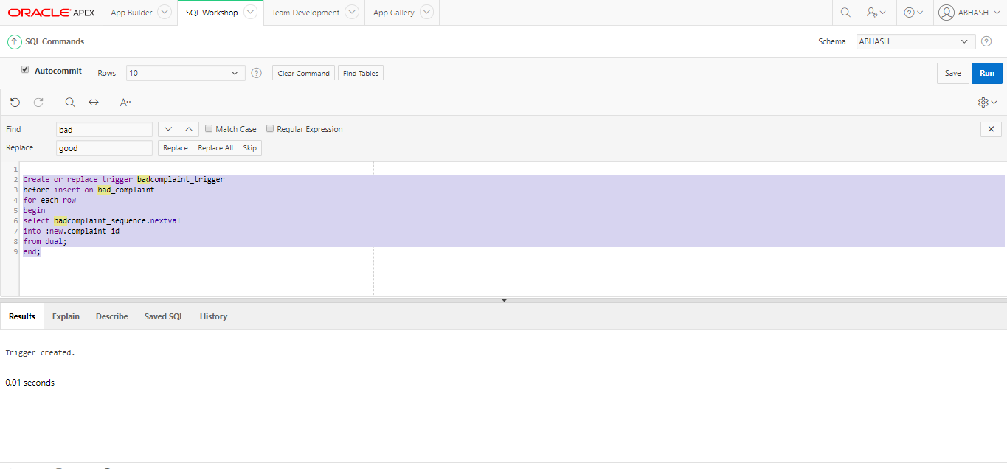

**Above screenshot shows Creating trigger for table bad_complaint**

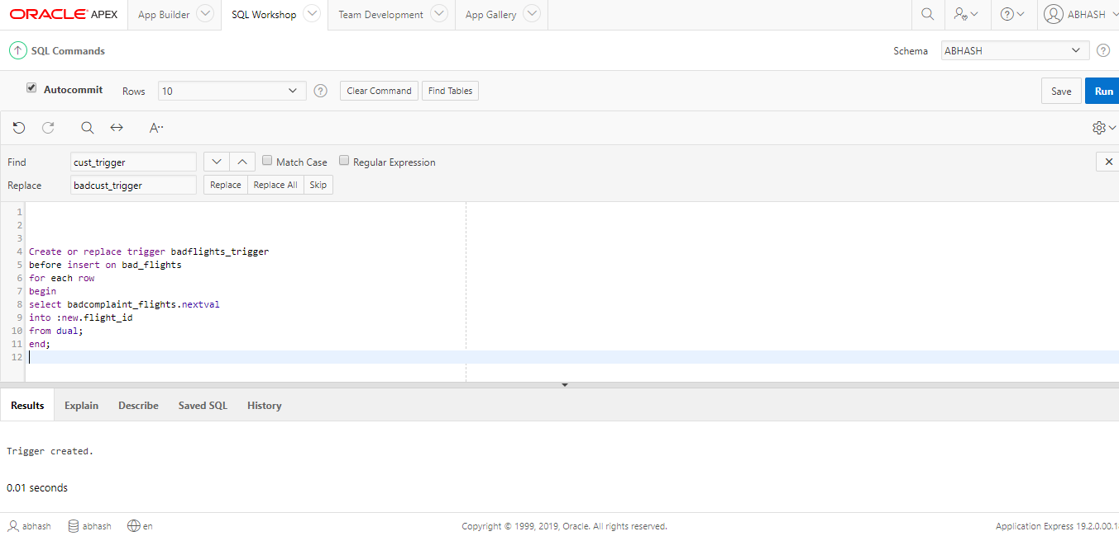

**Above screenshot shows Creating trigger for table bad_flights**

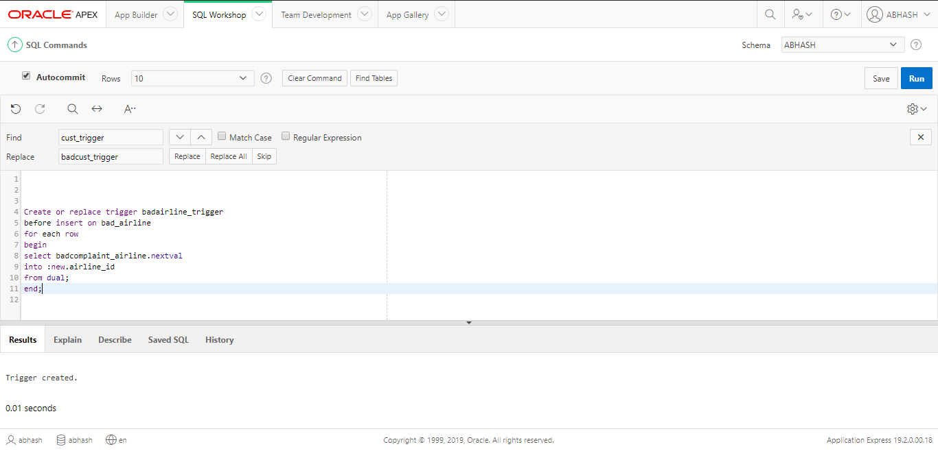

**Above screenshot shows Creating trigger for table bad _airline**

## Good data tables

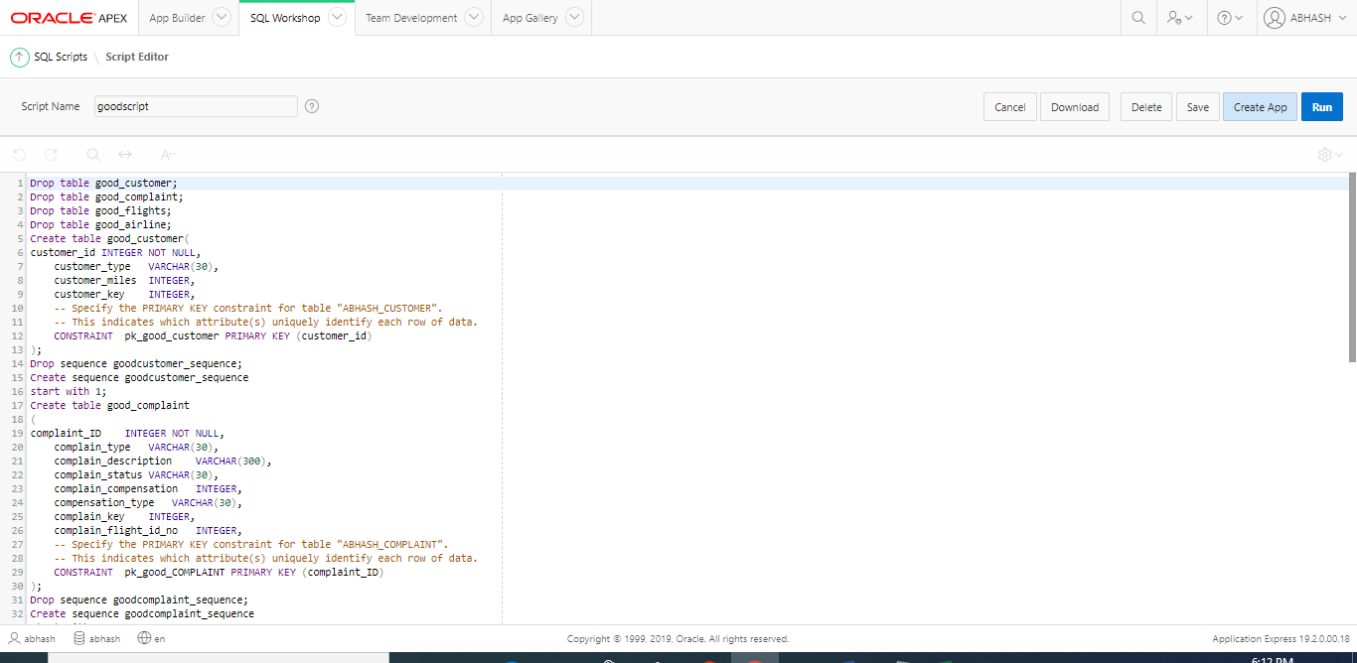

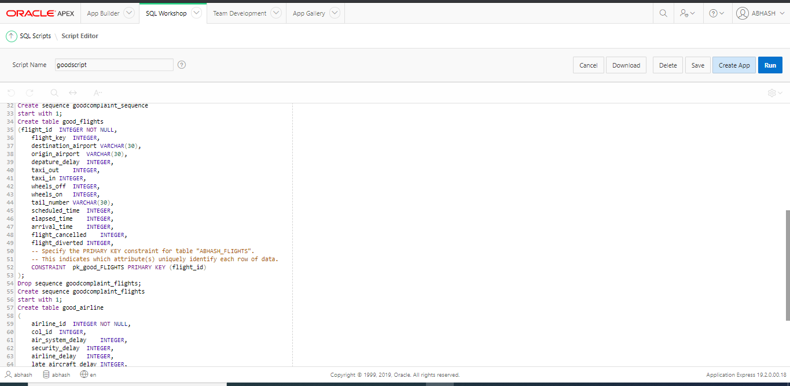



**Above screenshot shows Creating good data table’s good_customer, good_complaint, good_airline, good_flights and it sequences.**

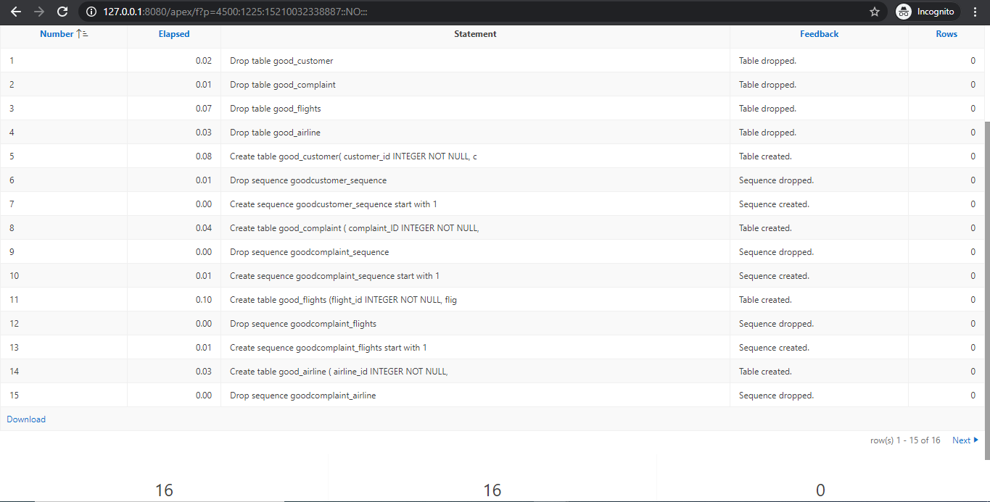

**Above screenshot shows Table’s and sequences created sucessfully**

## Creating good tables trigger

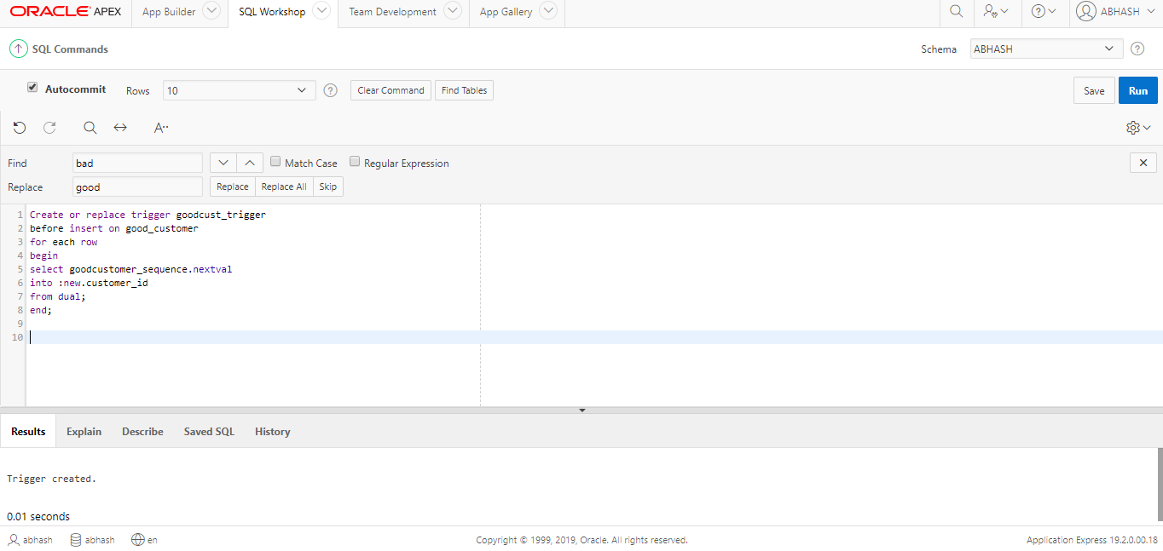

**Above screenshot shows Creating trigger for good table ‘good_customer’**

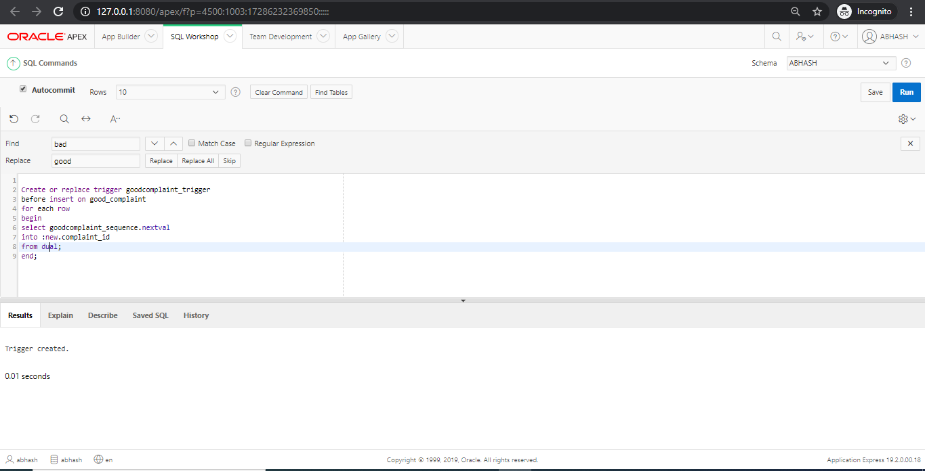

**Above screenshot shows Creating trigger for good table ‘good_complaint’**

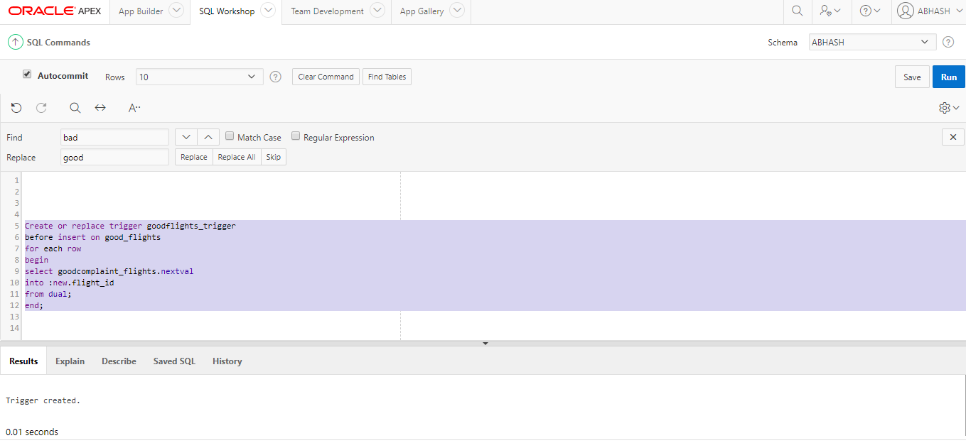

**Above screenshot shows Creating trigger for good table ‘good_flights’**

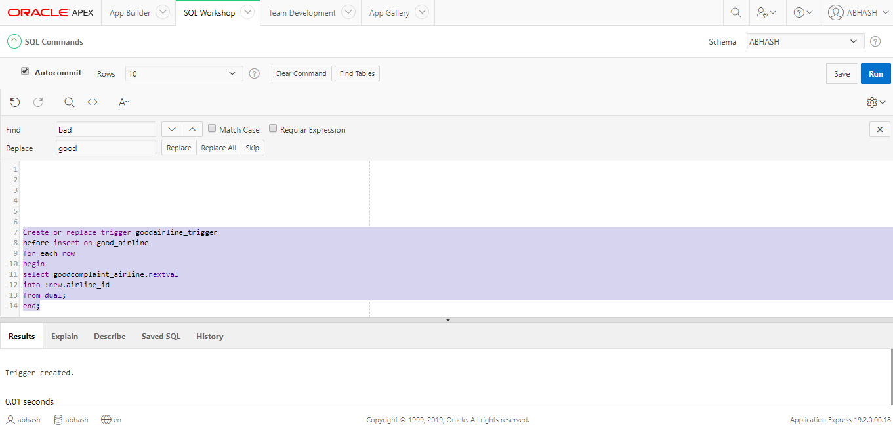

**Above screenshot shows Creating trigger for good table ‘good_airline’**

## Transmission

## Procedure creation for loading into bad data tables from staging table

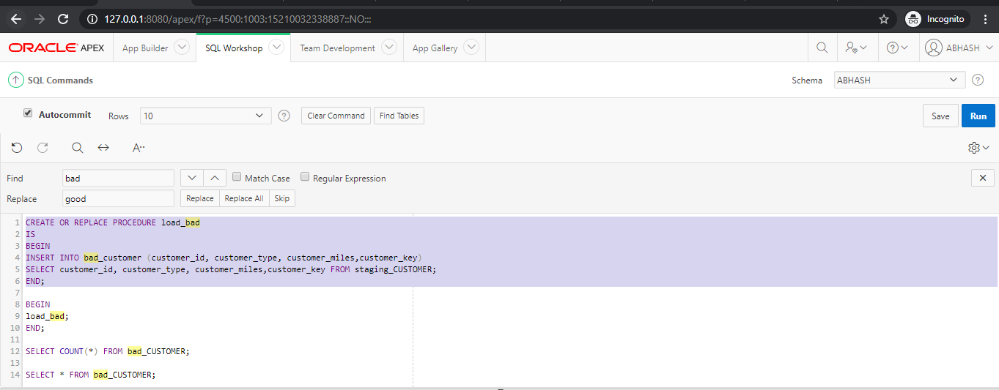

**Above screenshot shows Creating procedure for loading staging table ‘staging_customer’ data into bad table ‘bad_customer’**

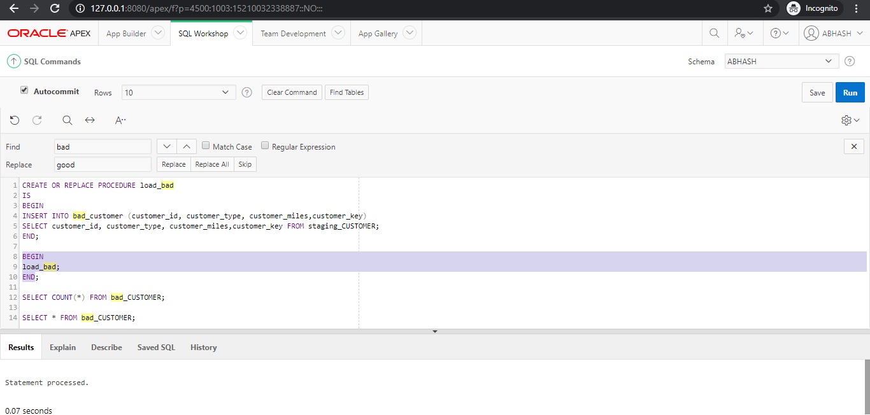

**Above screenshot shows Running the procedure**

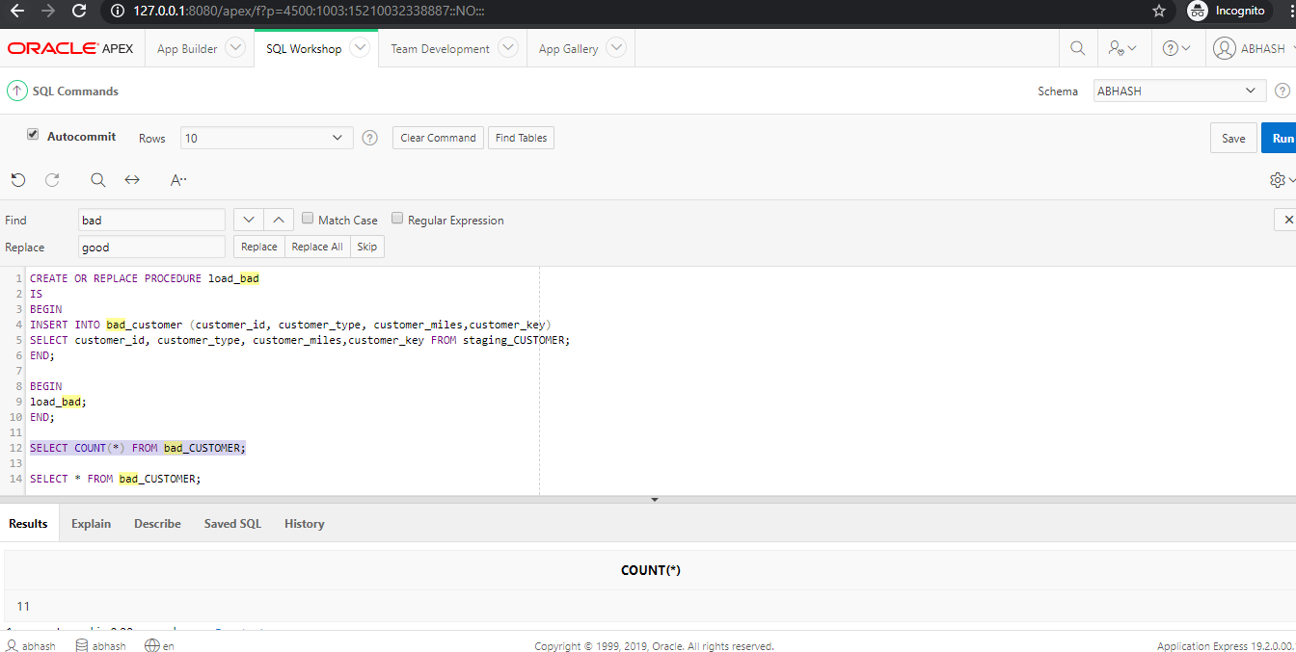

**Above screenshot shows Testing whether data has been loaded into bad table or not**

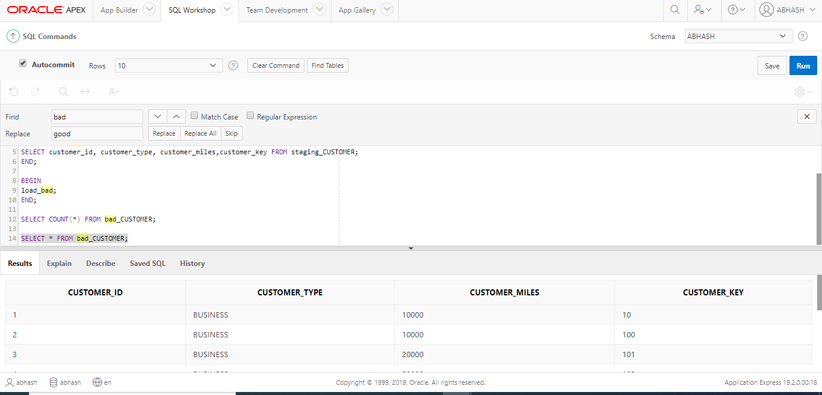

**Above screenshot shows Data loaded into bad table bad_customer**

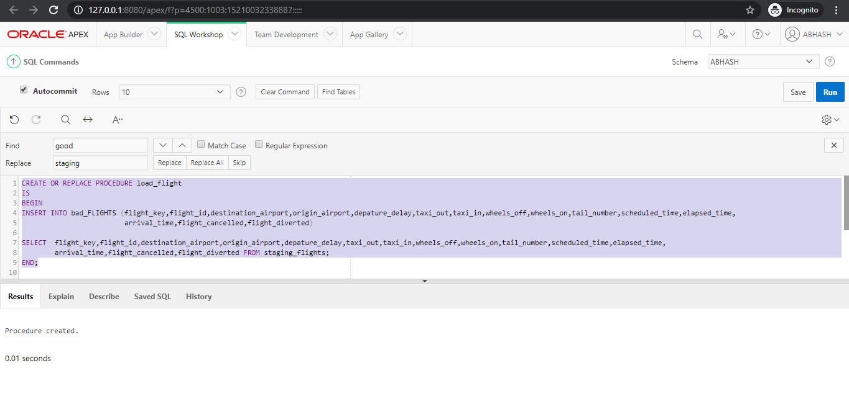

**Above screenshot shows Creating procedure for loading staging table ‘staging_flights’ into bad table ‘bad_flights’**

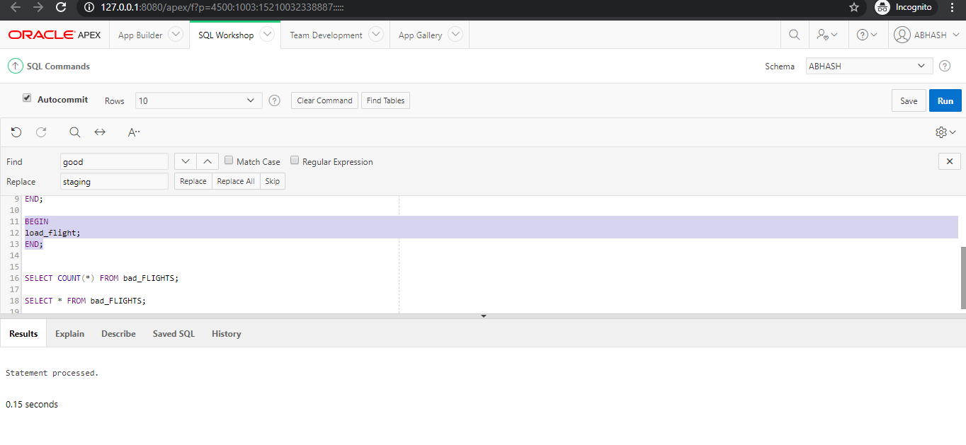

**Above screenshot shows Running the procedure**

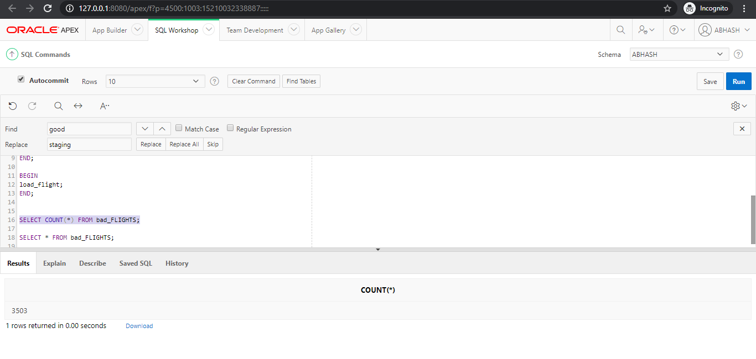

**Above screenshot shows Testing whether data has been loaded into bad table or not**

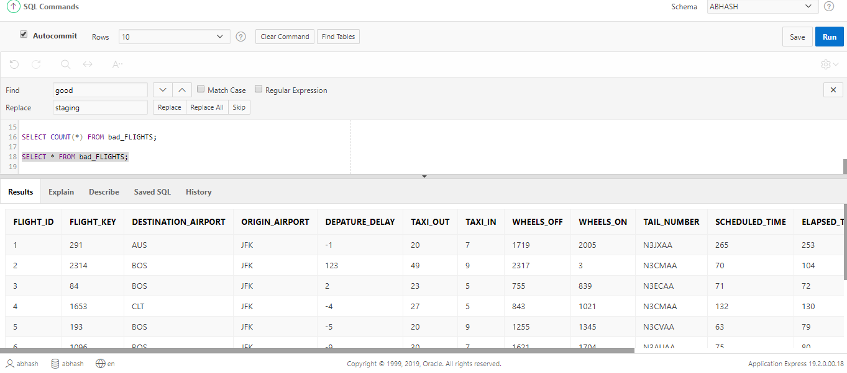

**Above screenshot shows Checking whether that data has been loaded into bad_flights**

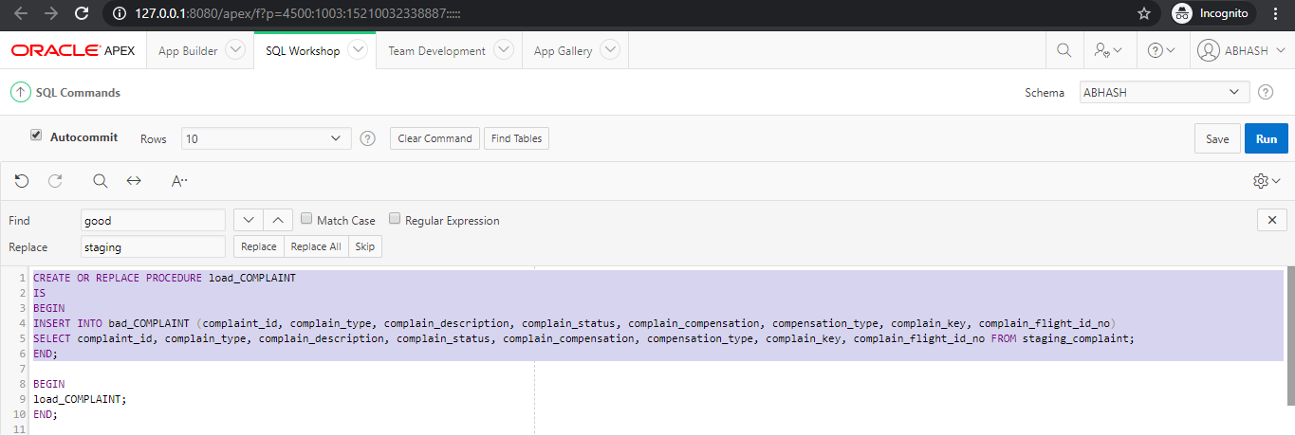

**Above screenshot shows Creating procedure for loading staging table ‘staging_complaint’ data into bad table ’bad_complaint’**

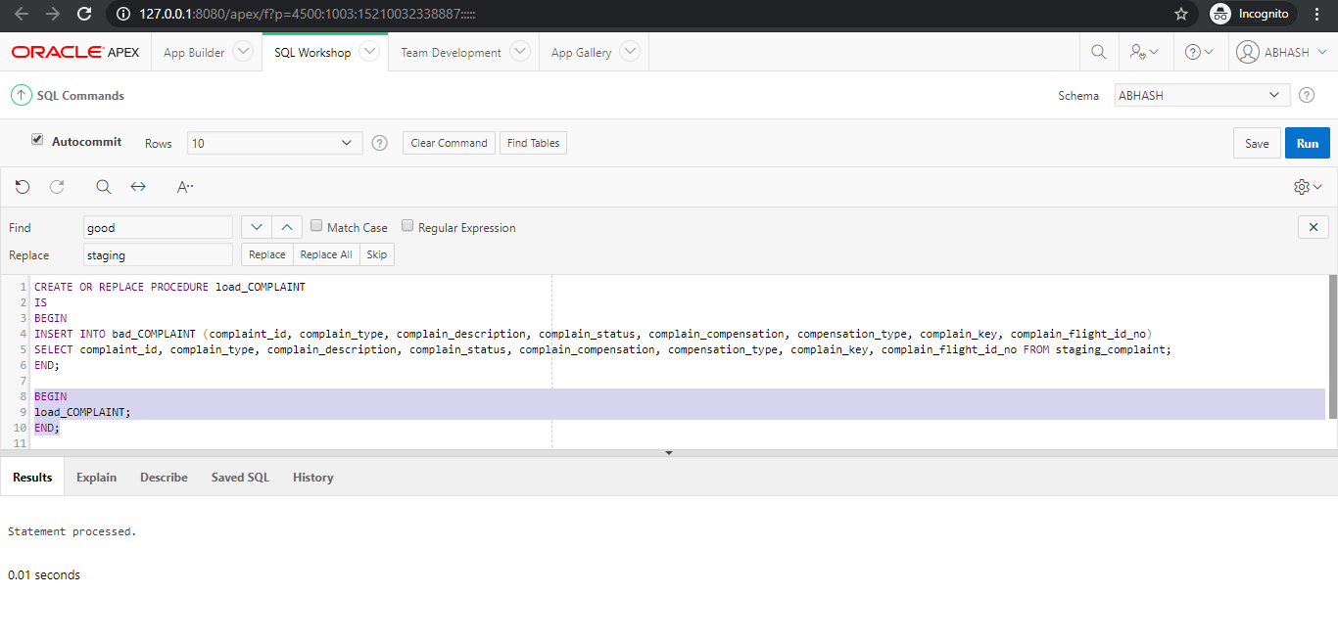

**Above screenshot shows Running the procedure**

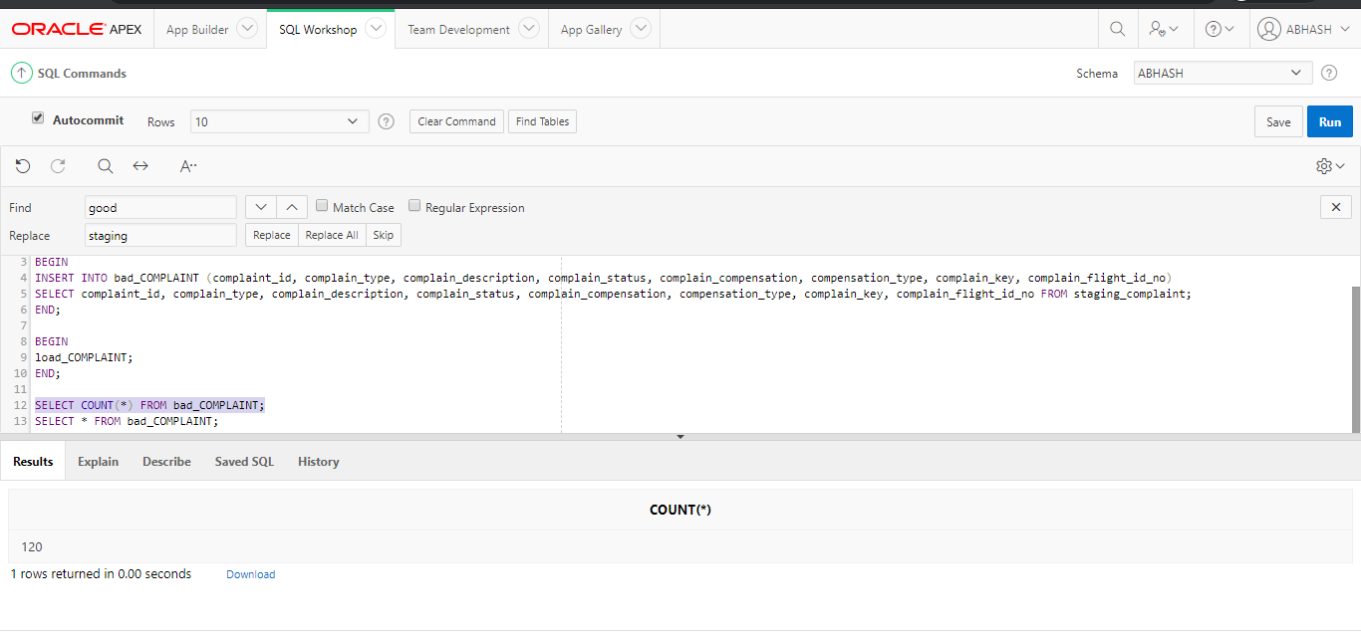

**Above screenshot shows Testing whether data has been inserted or not**

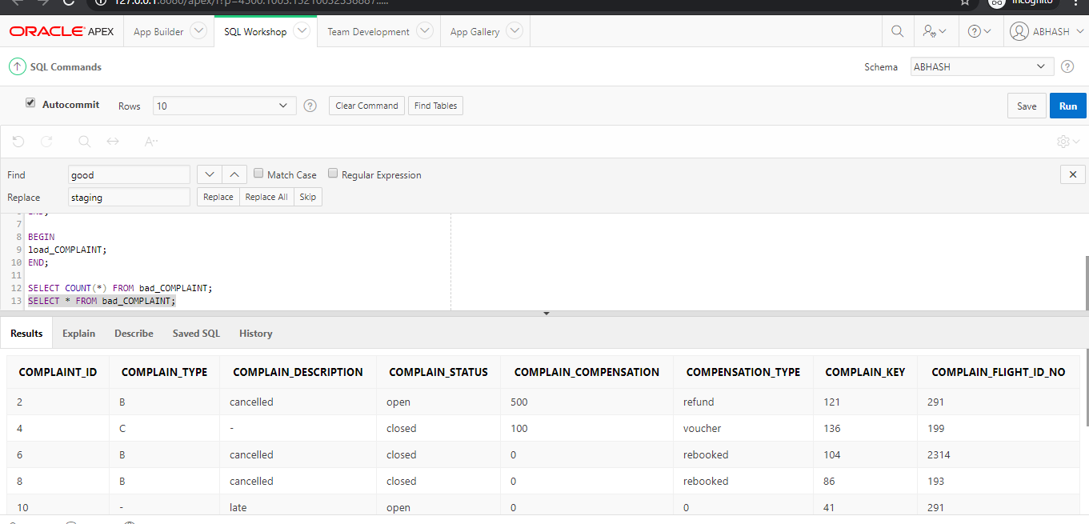

**Above screenshot shows Checking whether data has been inserted into bad_complaint**

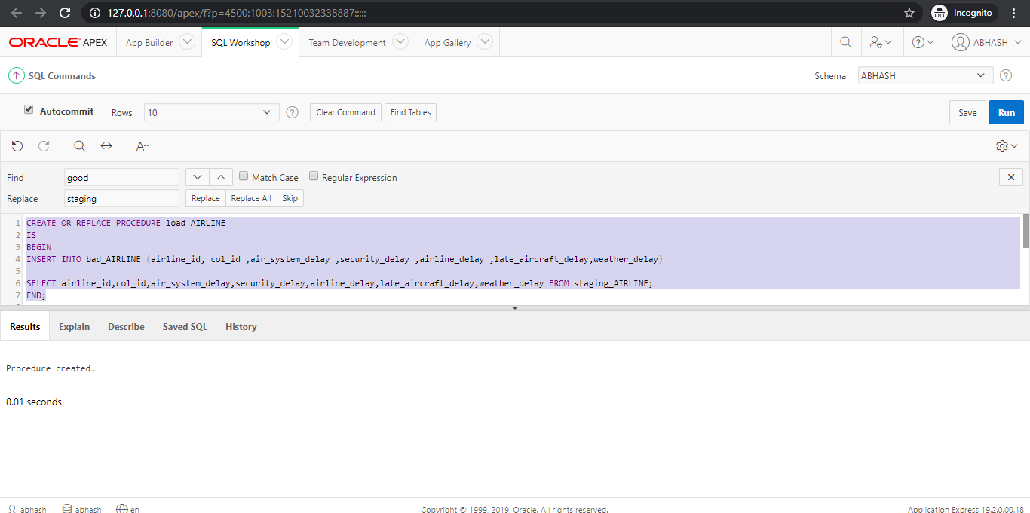

**Above screenshot shows Creating procedure for loading staging table ‘staging_airline’ data into bad table ‘bad_airline’**

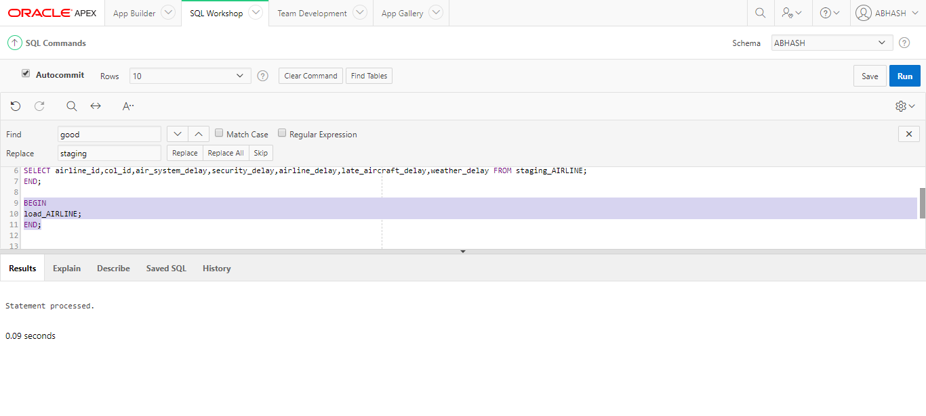

**Above screenshot shows Running the procedure**

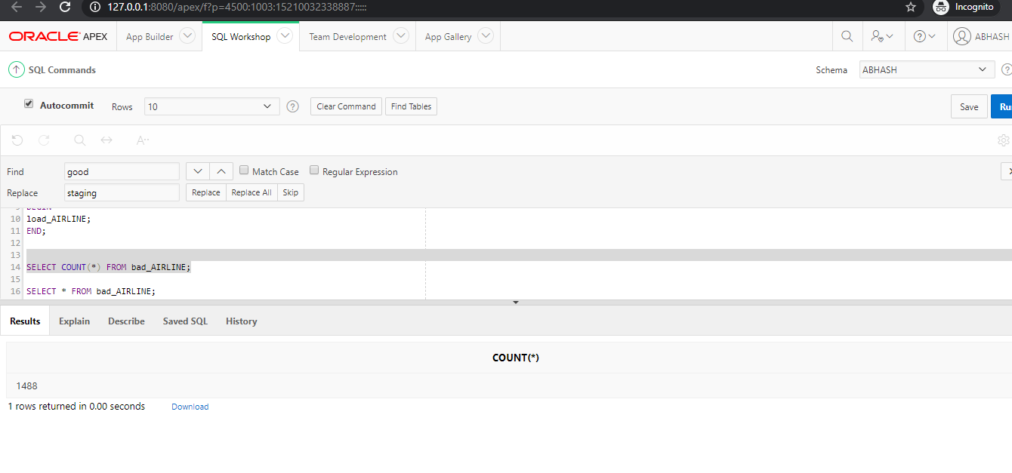

**Above screenshot shows Testing whether data exists or not**

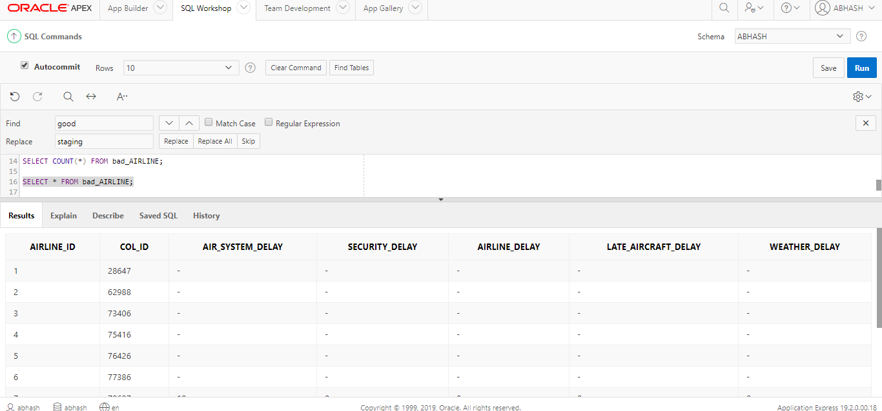

**Above screenshot shows Checking if data has been inserted into bad_airline**

**Creating bad data**

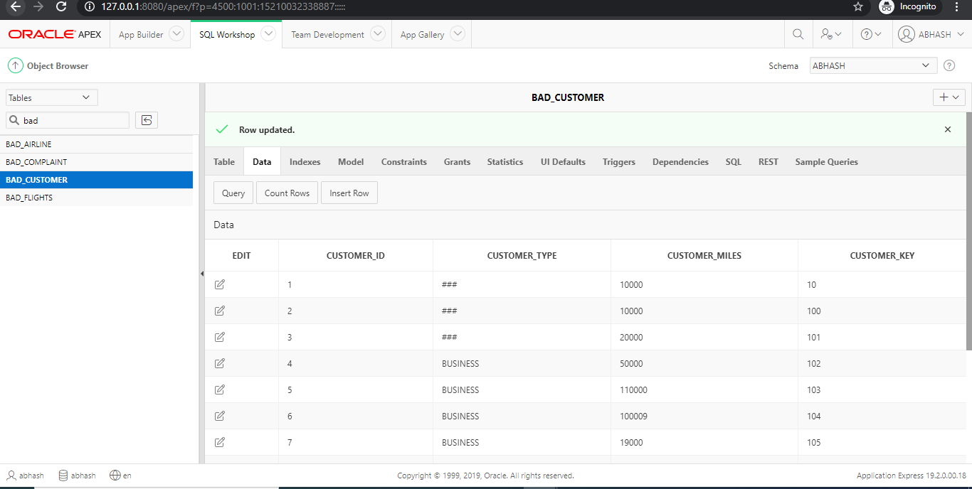

**Above screenshot shows Creating bad data for table bad_customer**

## Procedure creation for cleaning bad data and loading it into good data table

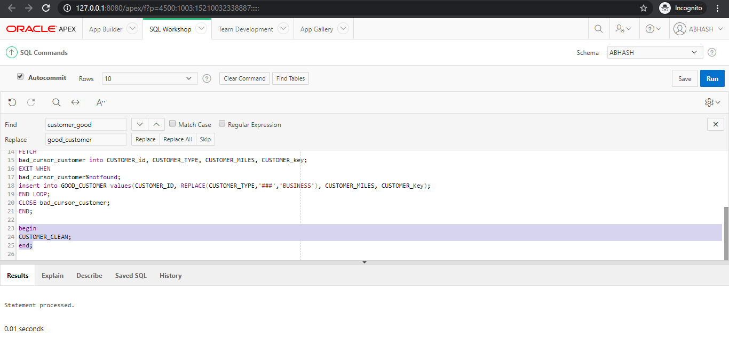 **Above screenshot shows Creating and running procedure for cleaning bad data and loading it into ‘good_customer’ table**

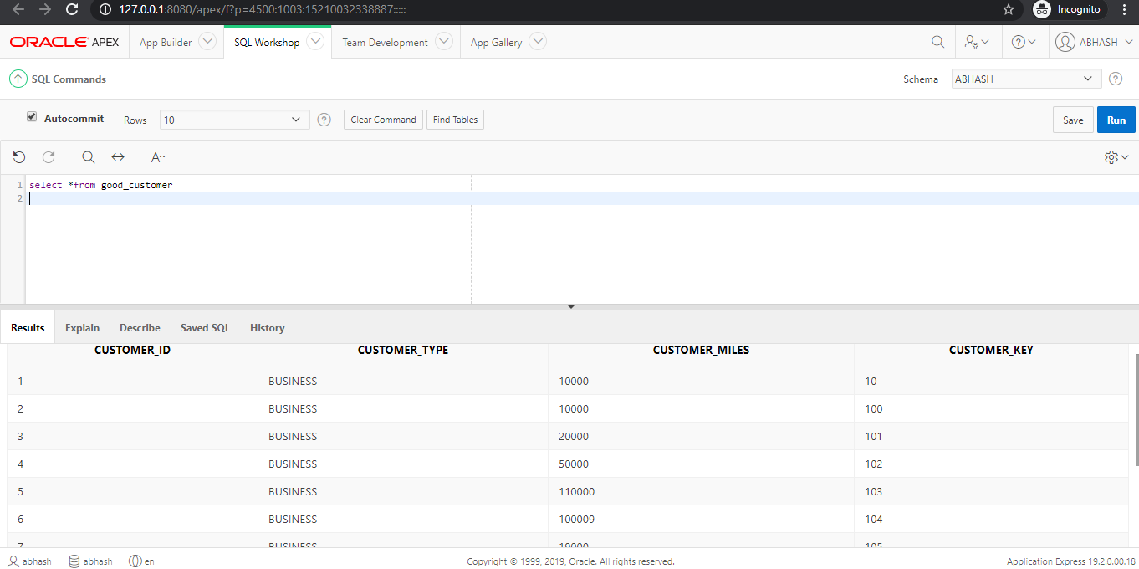

**Above screenshot shows Checking if data has been loaded into good table**

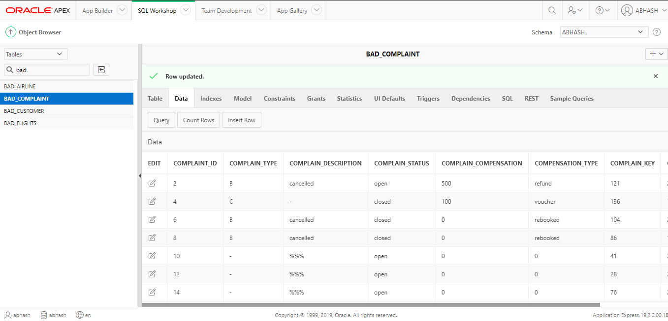

**Above screenshot shows Creating bad data for table bad_complaint**

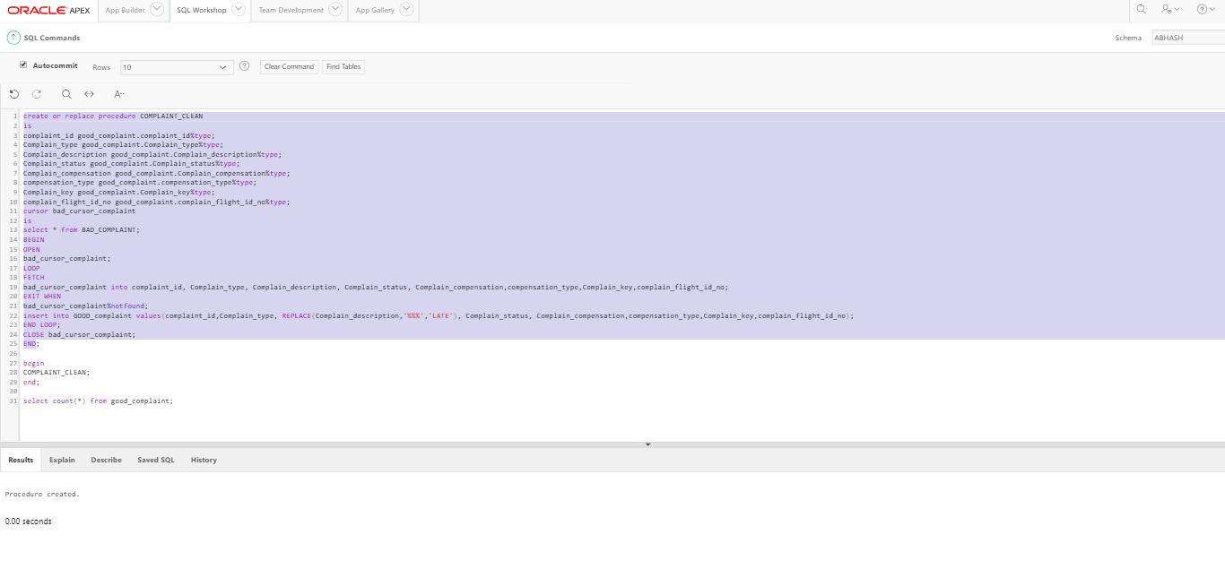

**Above screenshot shows Creating procedure and running it for cleaning bad data from bad table and loading it into good table ’good_complaint’**

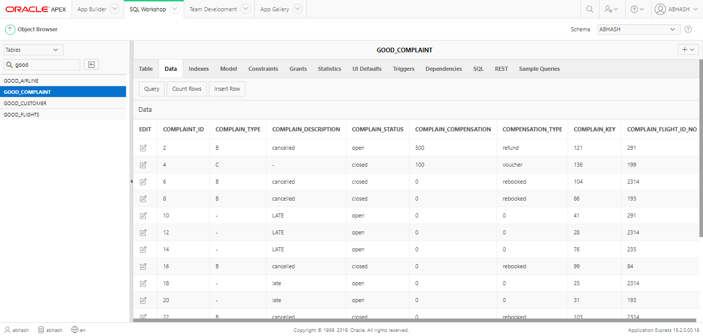

**Above screenshot shows Checking whether data has been loaded sucessfully**

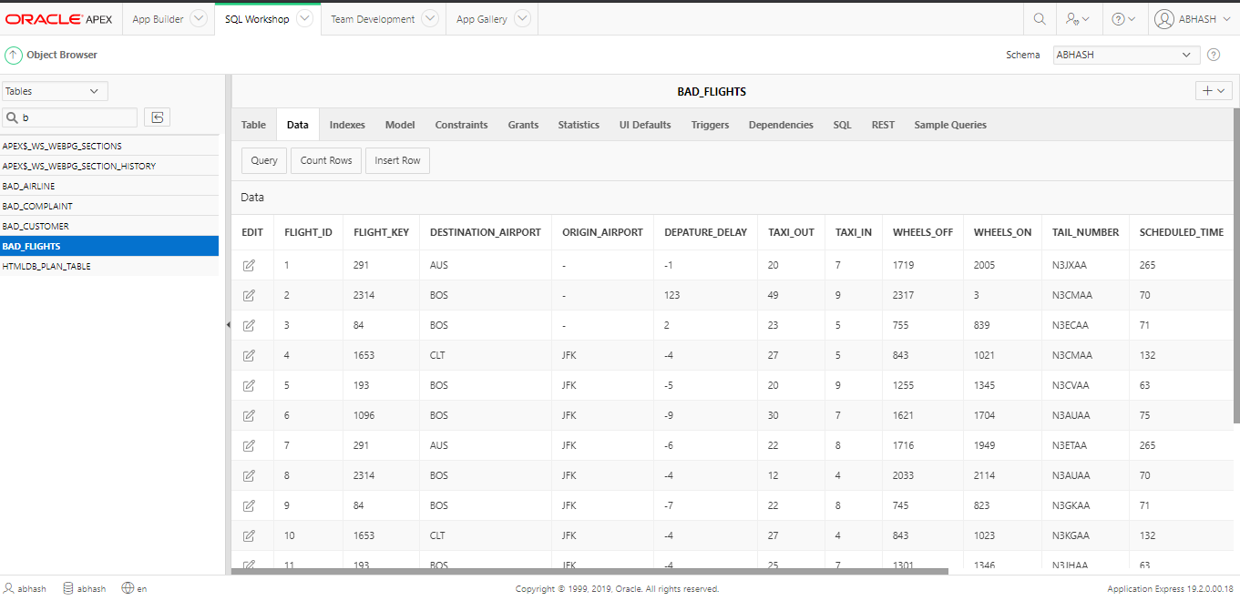

**Above screenshot shows Creating bad data for table bad_flights**

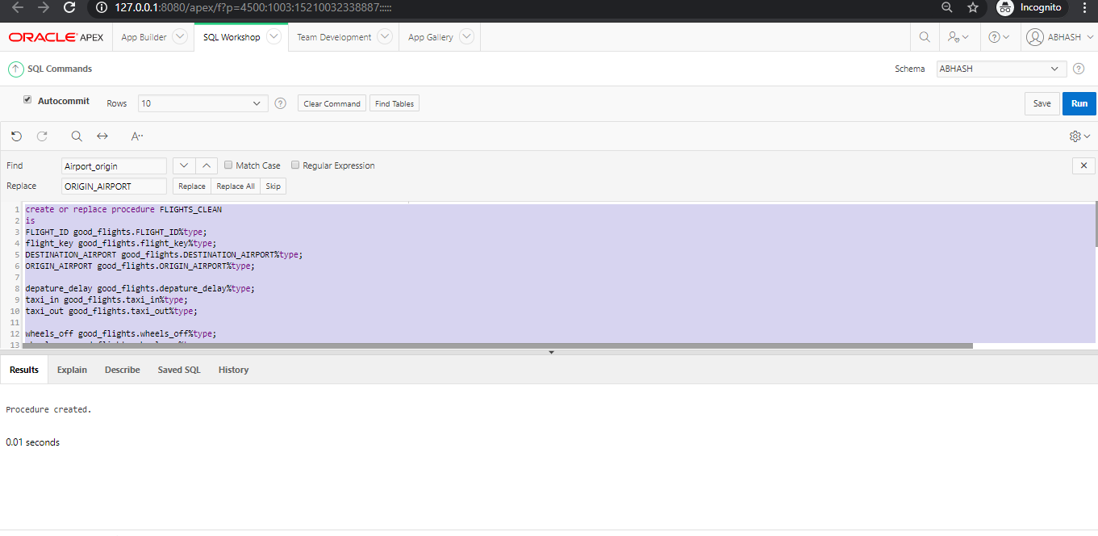

**Above screenshot shows Creating procedure and running it for cleaning bad datas from bad table and loading it into good table ’good_flights’**

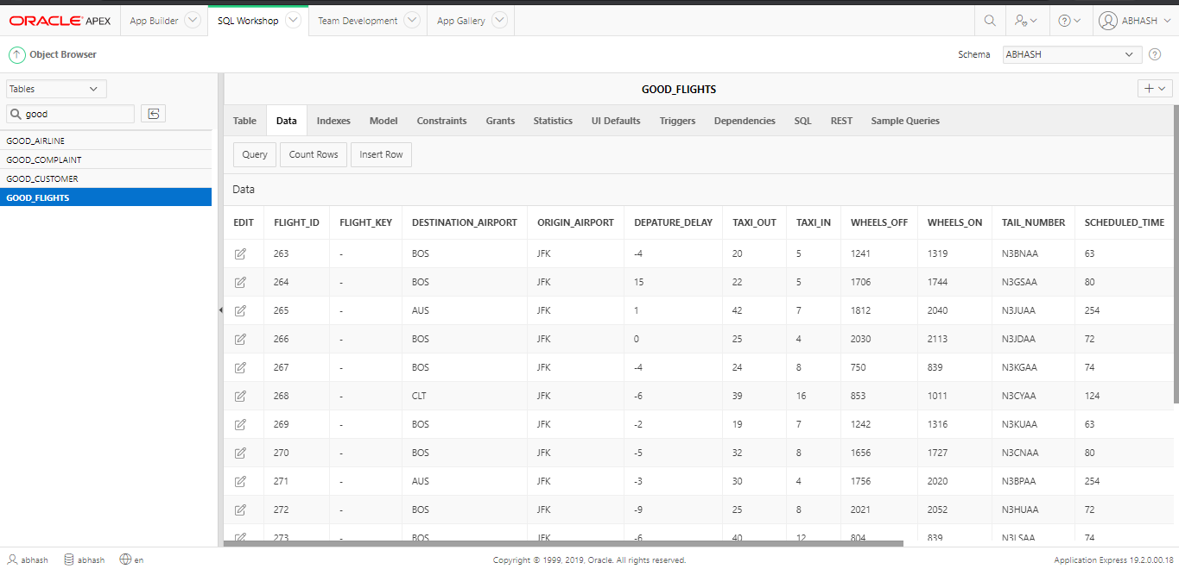

**Above screenshot shows Checking whether data has been loaded into good_flights or not**

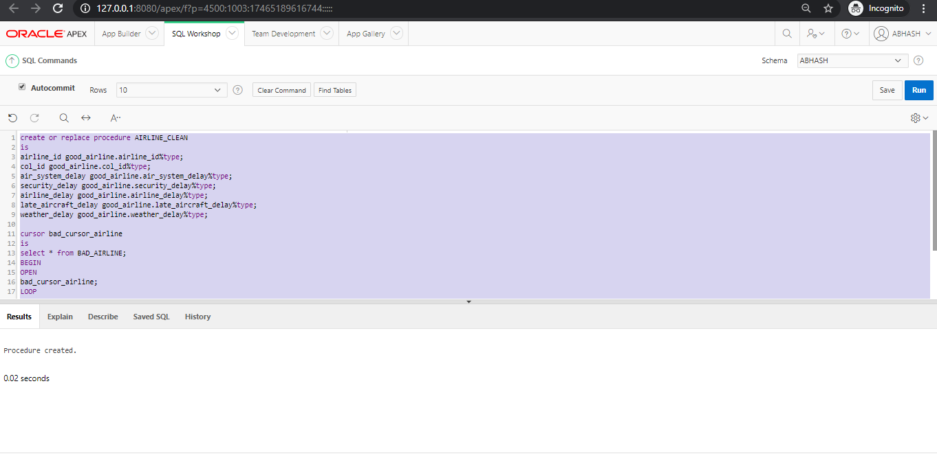

**Above screenshot shows Creating procedure Airline Clean and running it for cleaning bad data from bad table and loading it into good table ’good_airline’**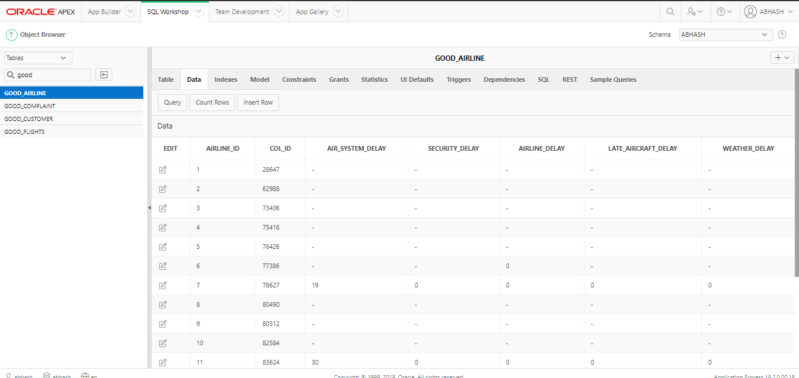

## Transformation

## Re cleaning

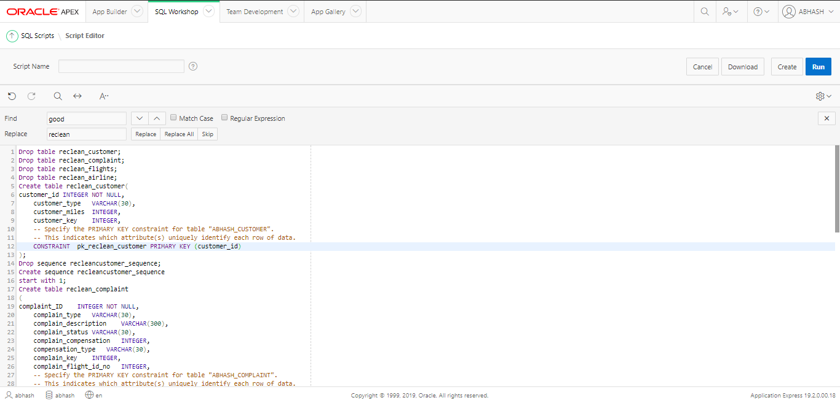

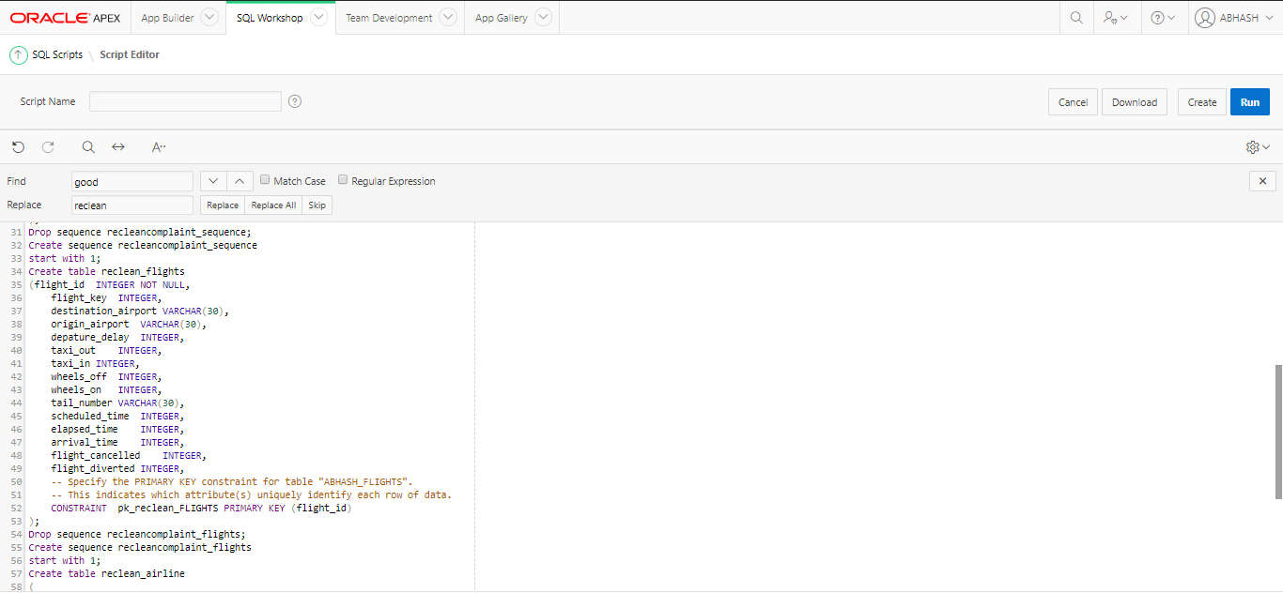

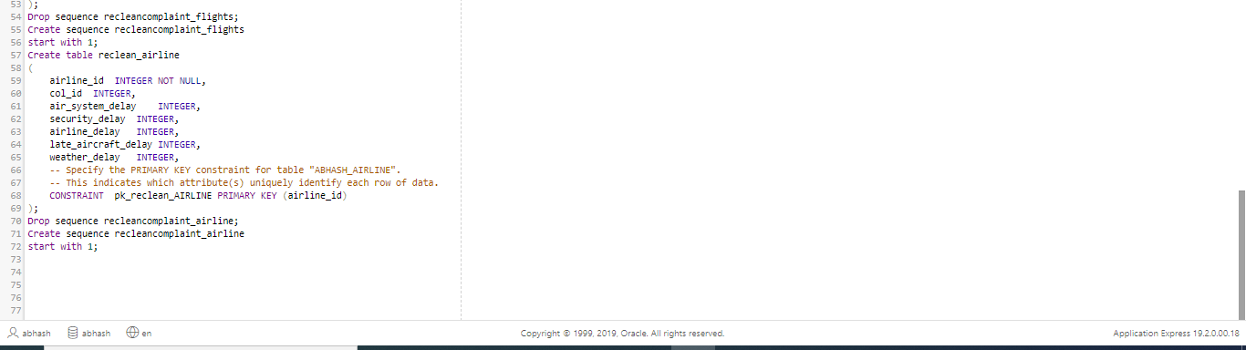 **Above screenshot shows Creating re cleaning tables reclean_customer, reclean_complaint, reclean_flights, reclean_airline**

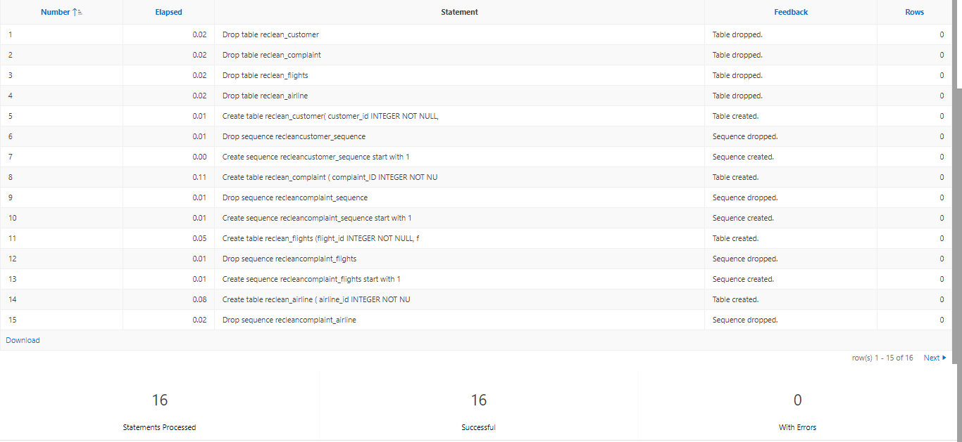

**Above screenshot shows Tables and sequence created sucessfully**

## Trigger creation for re clean

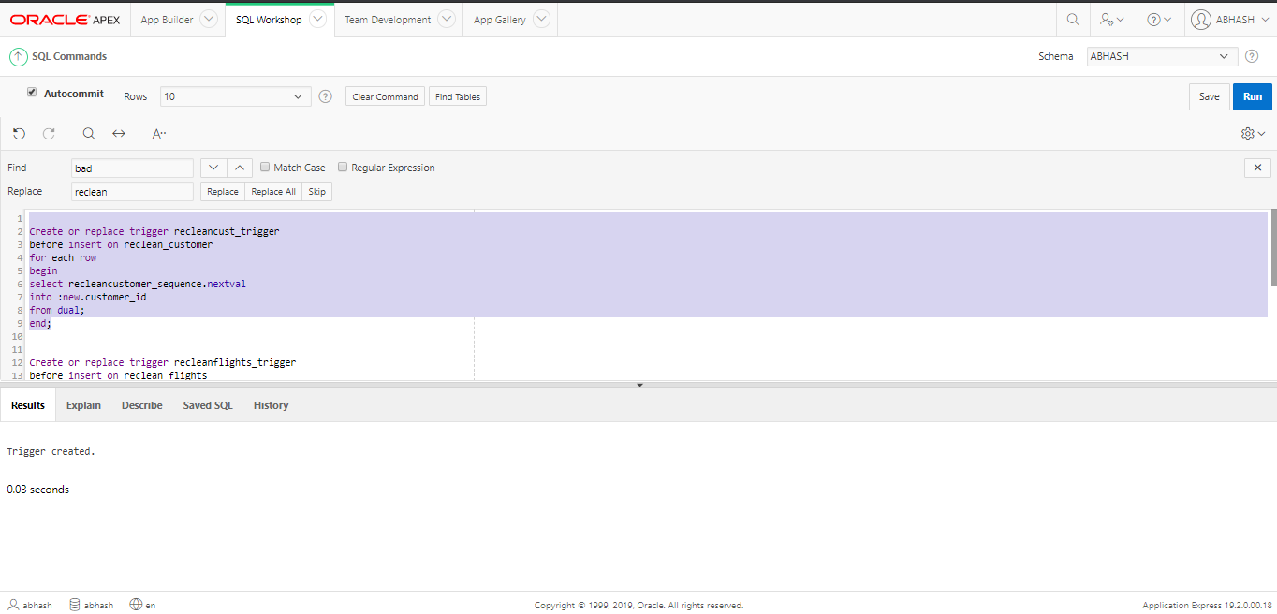

**Above screenshot shows Creating trigger for re clean table reclean_customer**

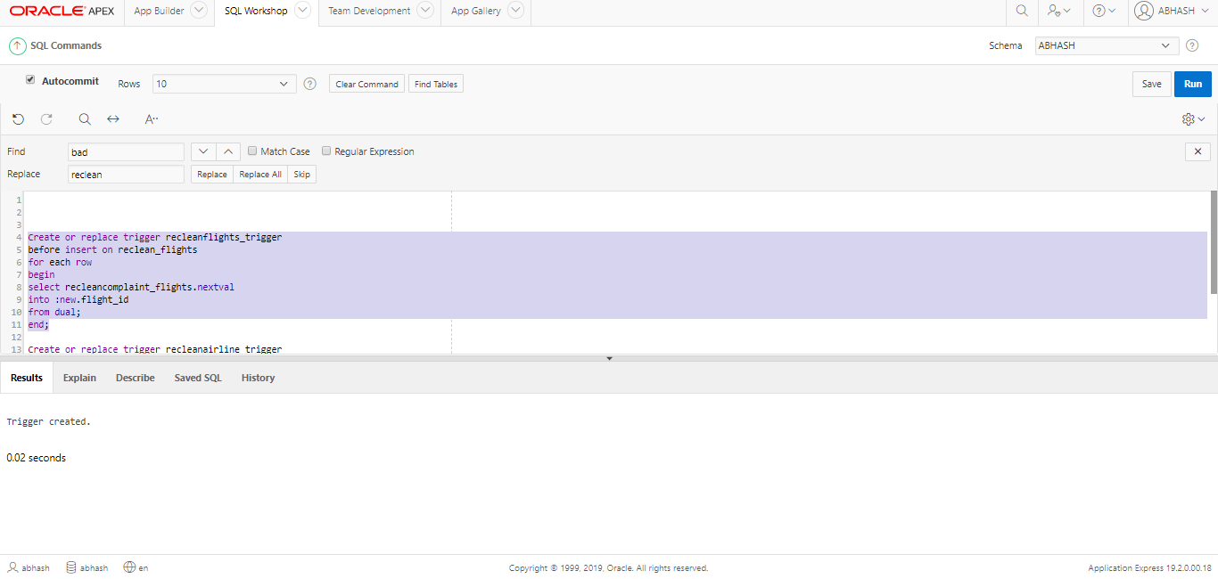

**Above screenshot shows Creating trigger for re clean table reclean_flights**

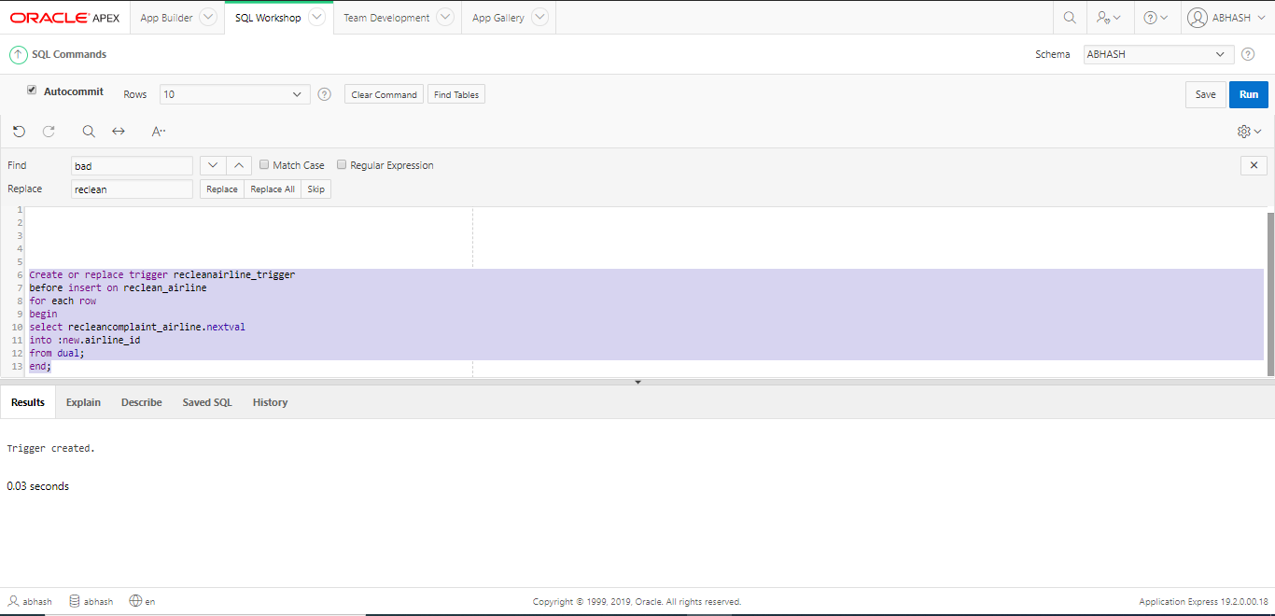

**Above screenshot shows Creating trigger for re clean table reclean_airline**

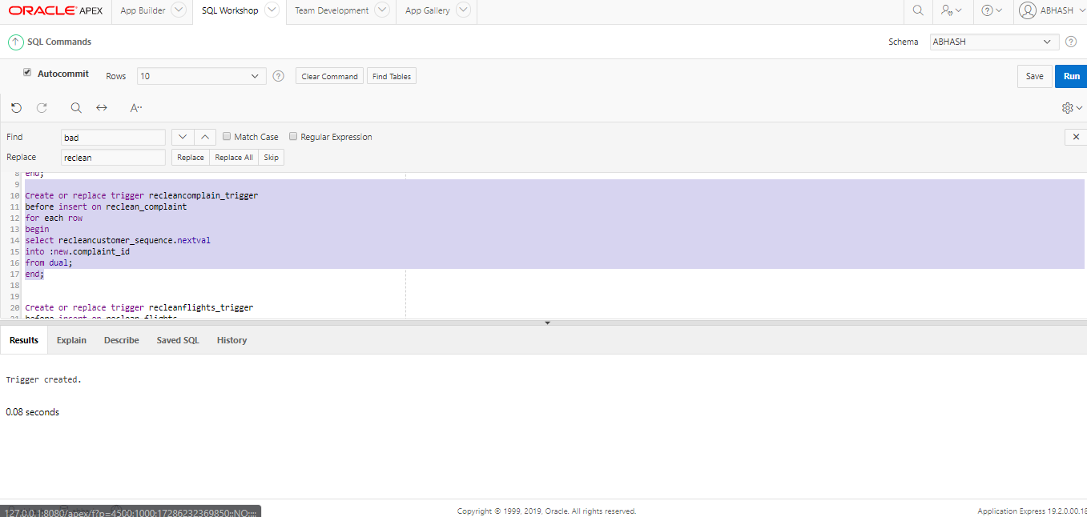

**Above screenshot shows Creating trigger for re clean table reclean_complaint**

## Procedure creation for re clean tables

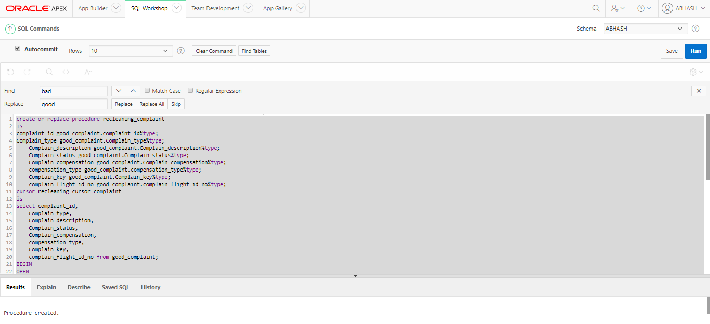

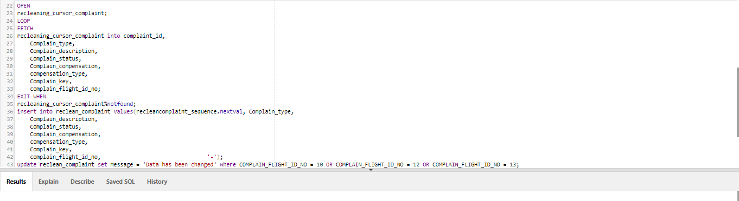

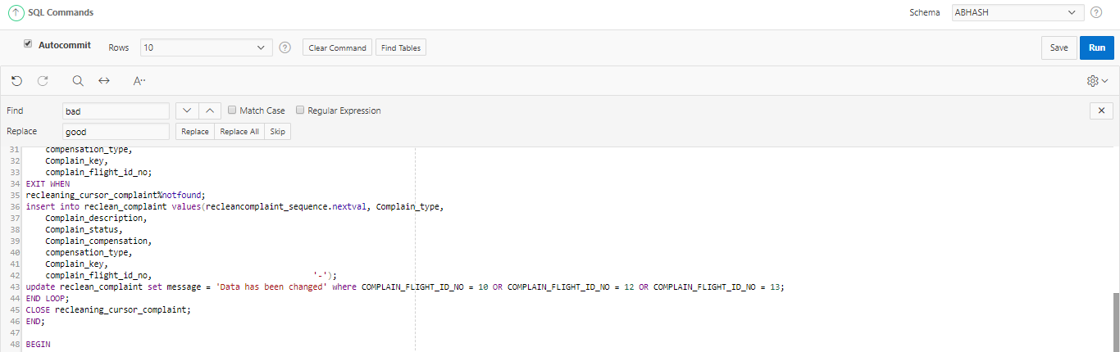

**Above screenshot shows Creating procedure recleaning_Complaint for showing “Data has been changed” message where data has been changed**

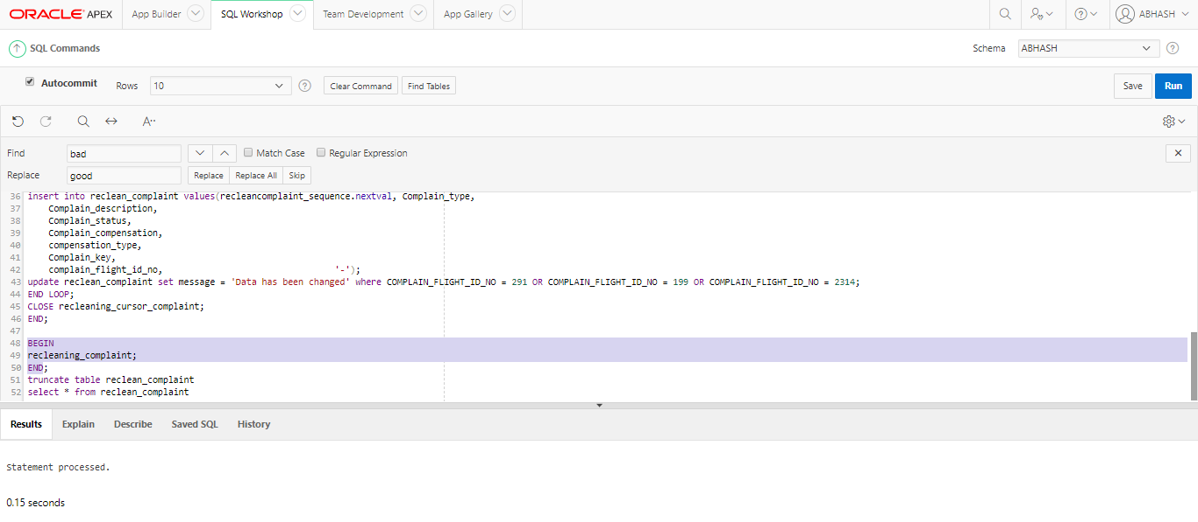

**Above screenshot shows Running the procedure**

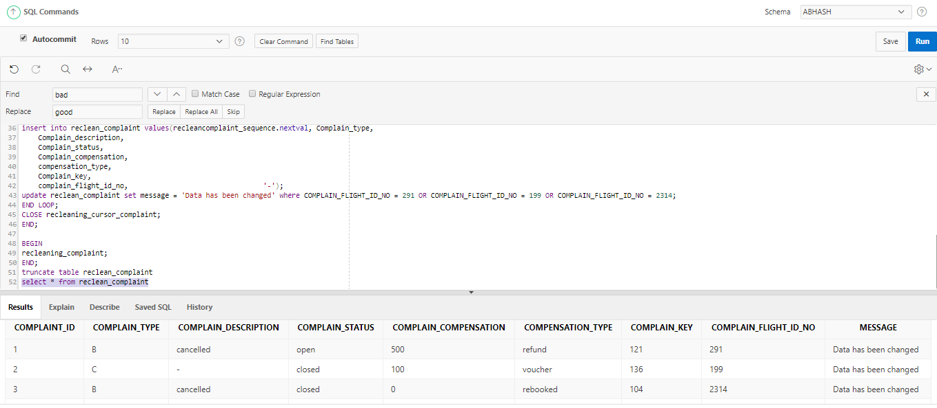

**Above screenshot shows Showing data has been changed message**

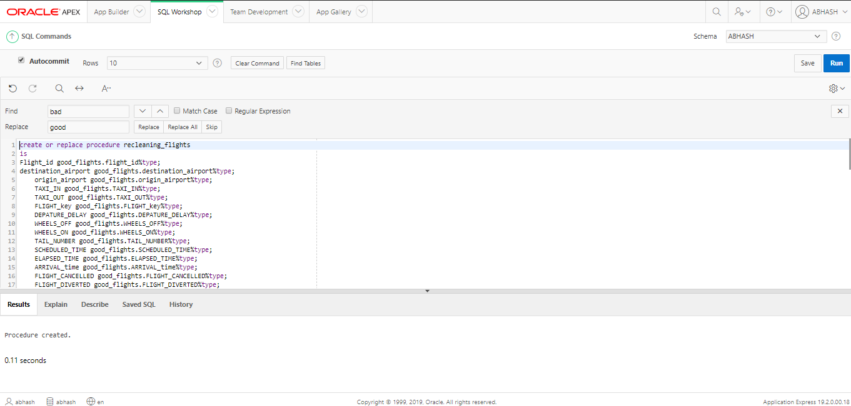

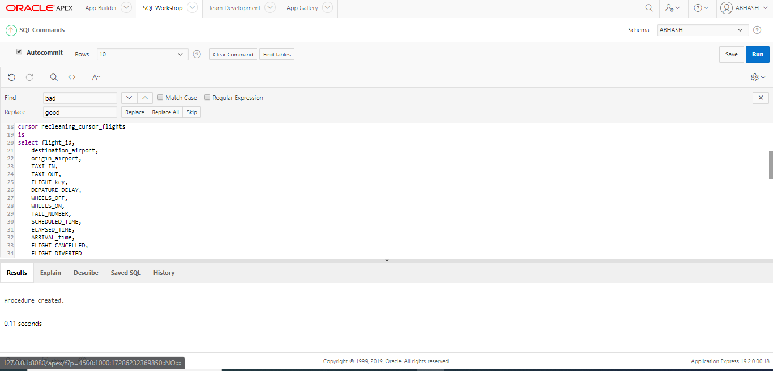

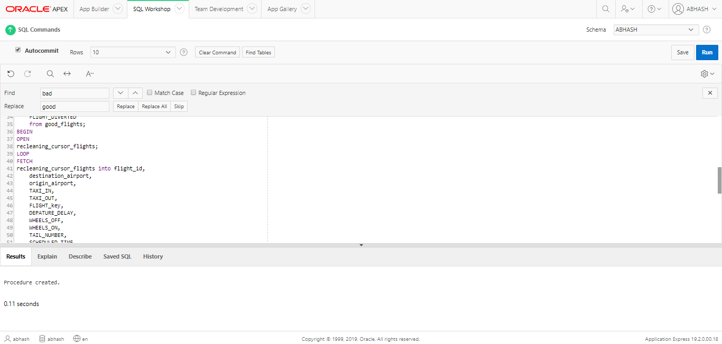

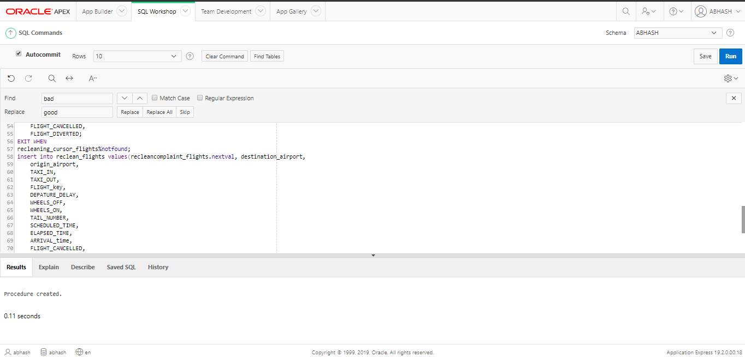

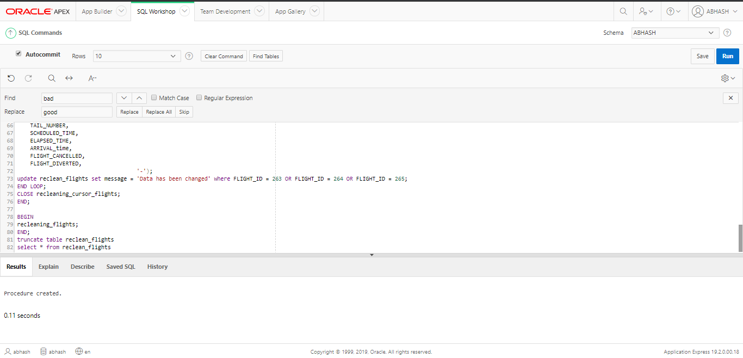

**Above screenshot shows Creating procedure recleaning_flights for showing “Data has been changed message” where data has been changed.**

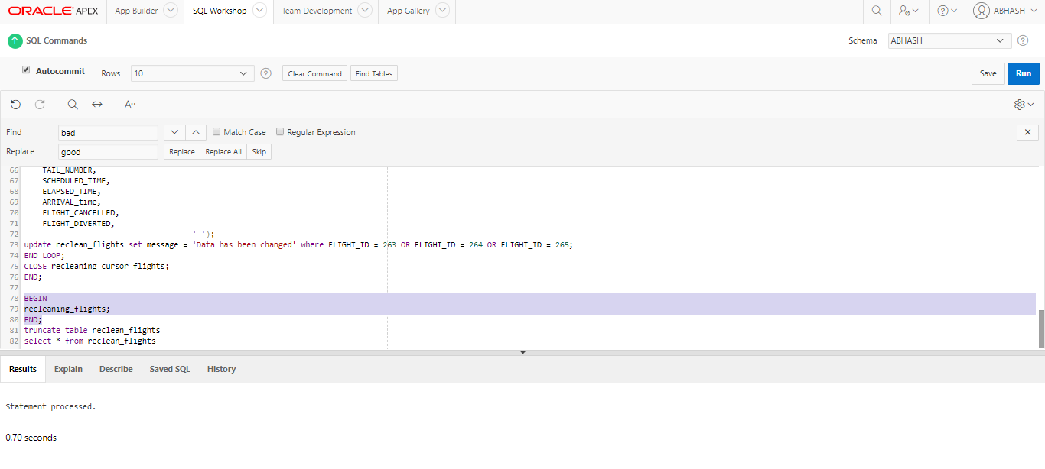

**Above screenshot shows Running the created procedure**

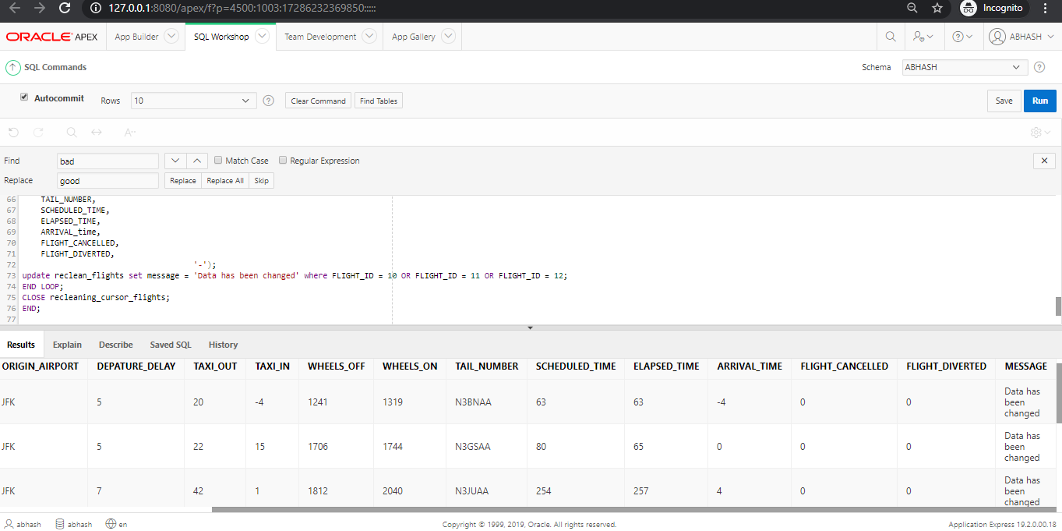

**Above screenshot shows Showing data has been changed method**

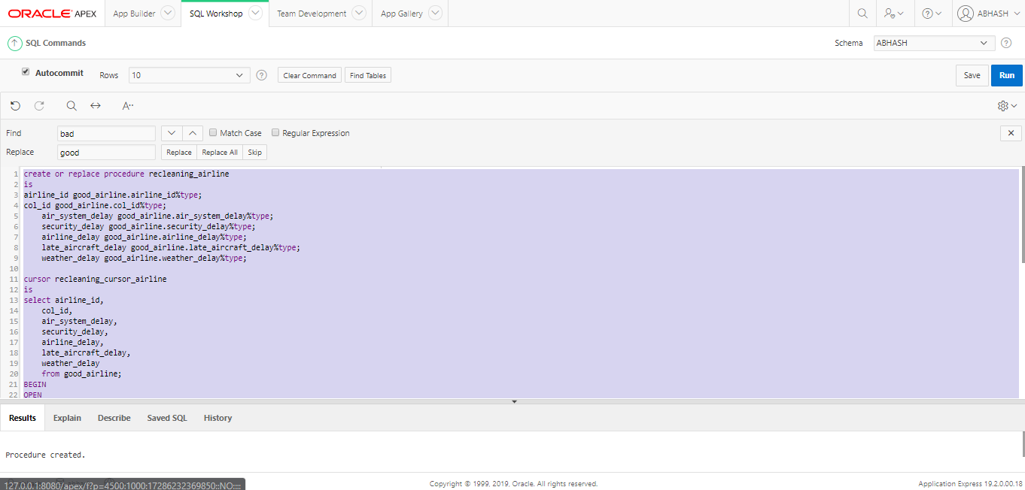

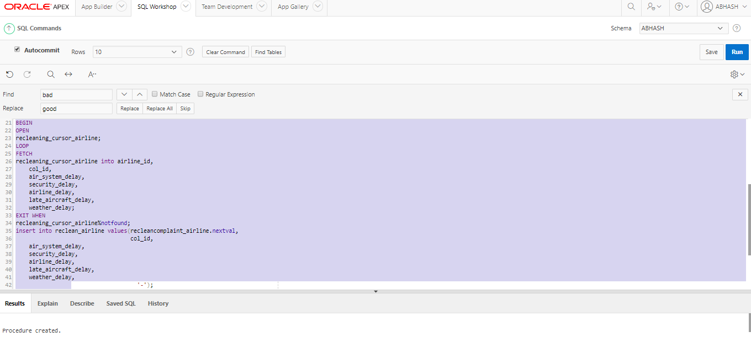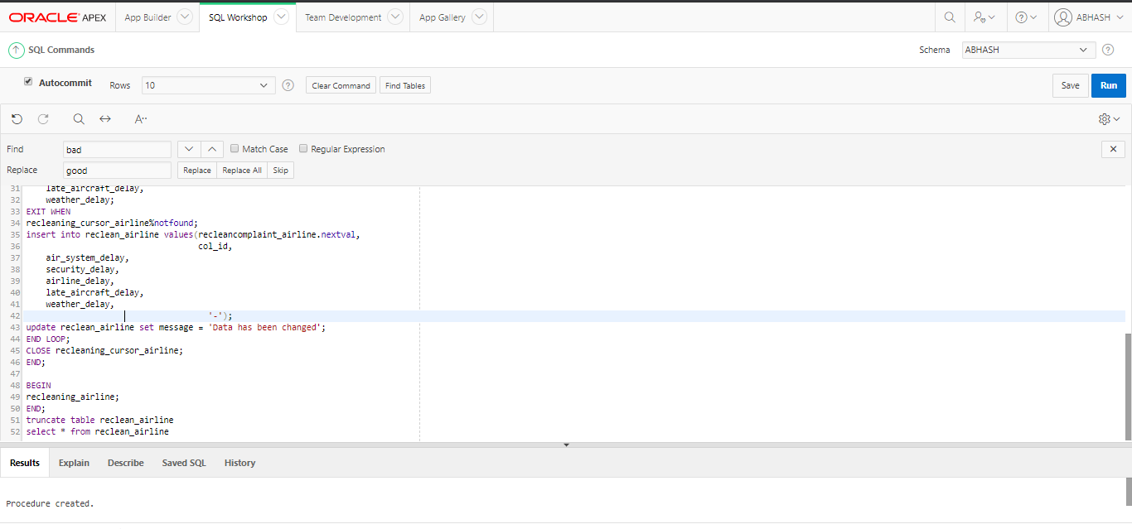

**Above screenshot shows Creating procedure to show “Data has been changed” message where data is changed**

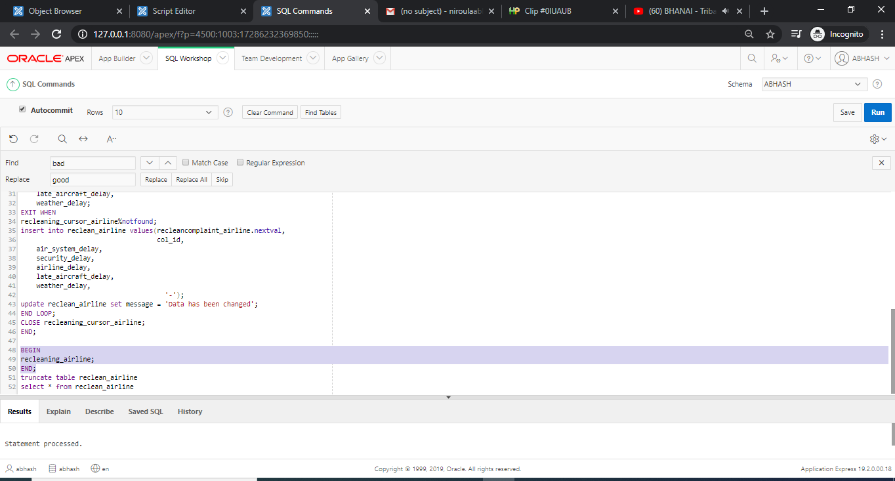

**Above screenshot shows Running the procedure**

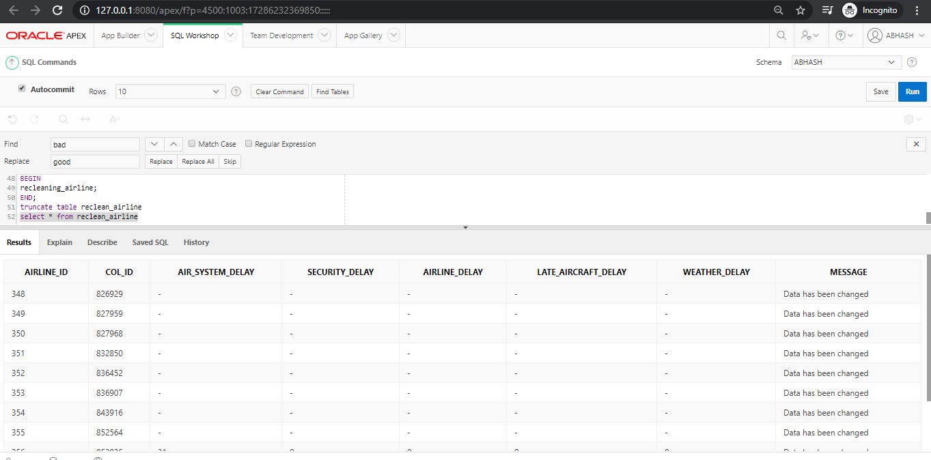

**Above screenshot shows Showing data has been changed method**

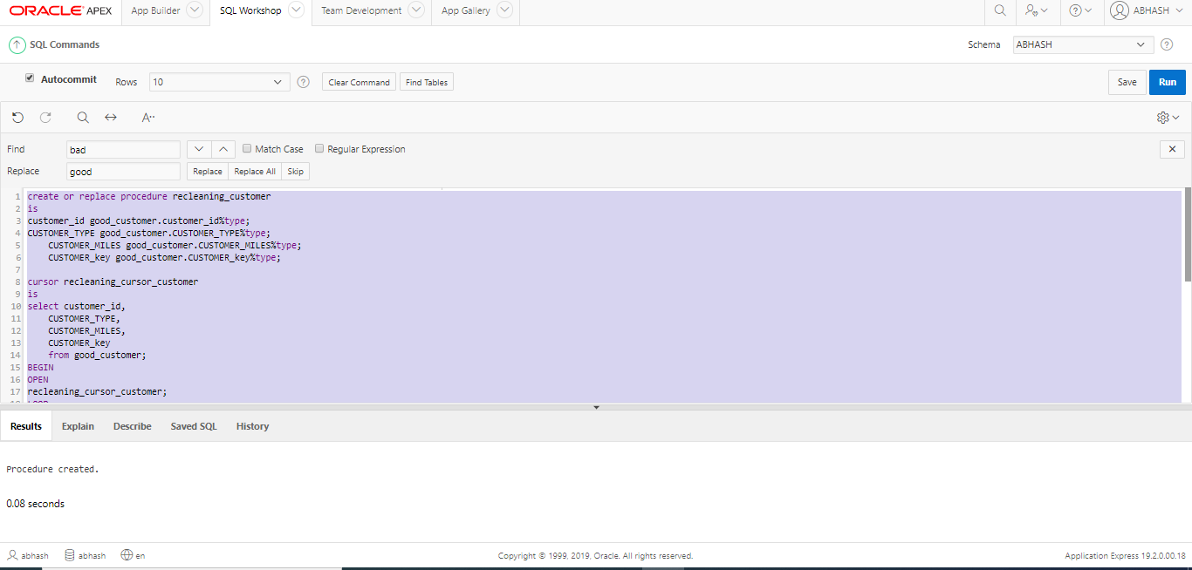

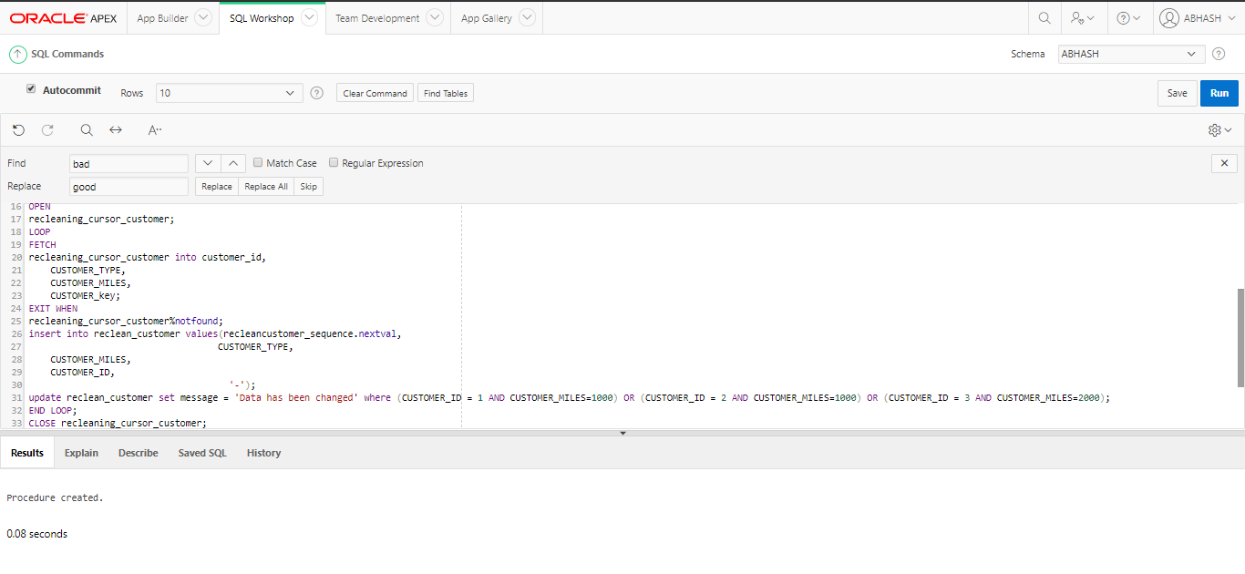

**Above screenshot shows Creating procedure recleaning_customer for showing “Data has been changed” message where data is changed.**

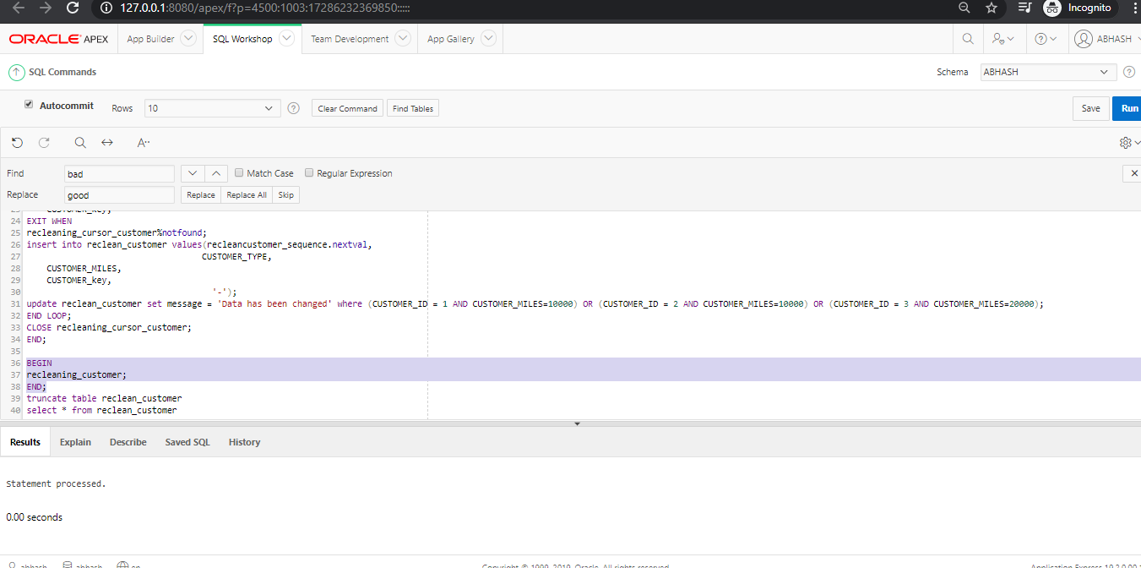

**Above screenshot shows Running the procedure**

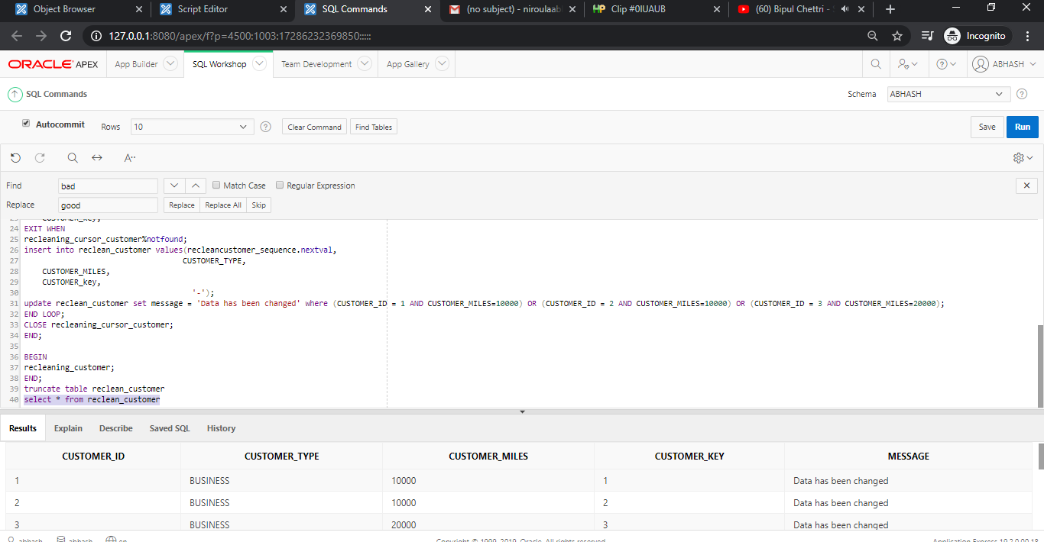

**Above screenshot shows Showing data has been changed method**

## Loading

## Procedure creation for loading Good table data into dim table

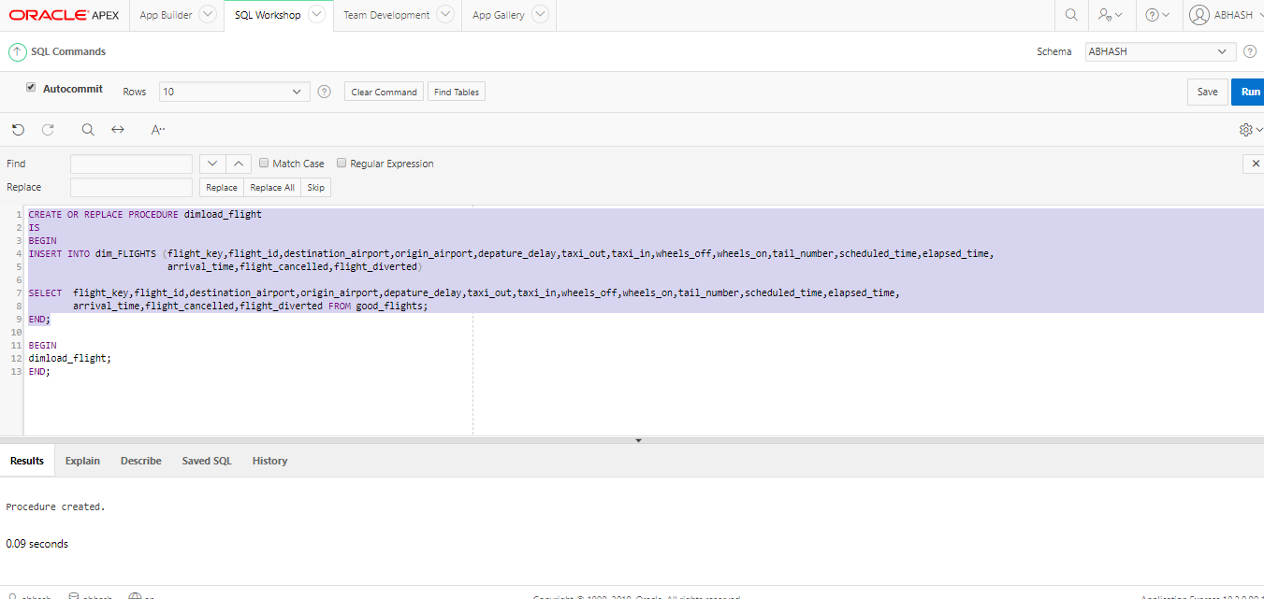

**Above screenshot shows Creating procedure for loading good_flights data into dimload_flight**

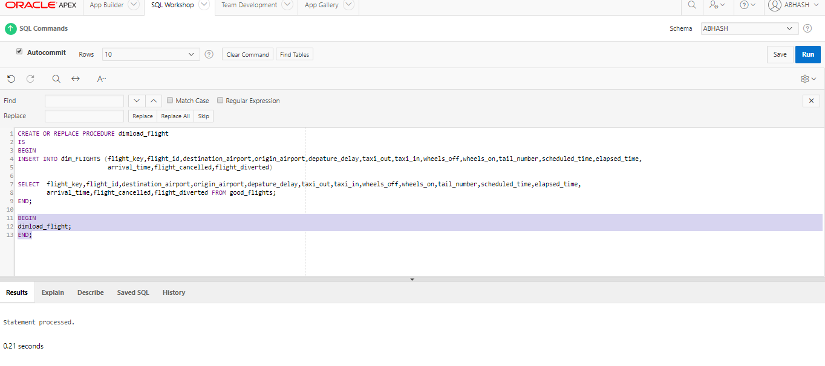

**Above screenshot shows Running the procedure**

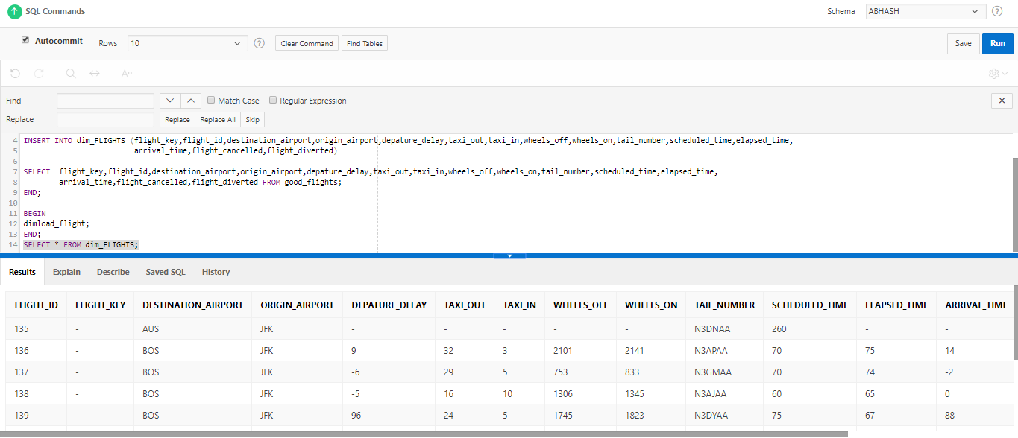

**Above screenshot shows Viewing loading data in dim_flights**

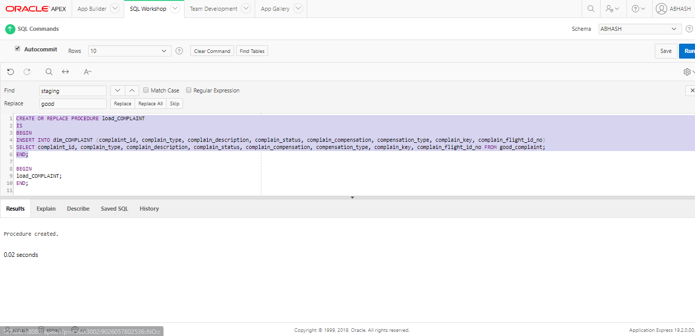

**Above screenshot shows Creating procedure load_complaint to load good_complaint data into dim_complaint**

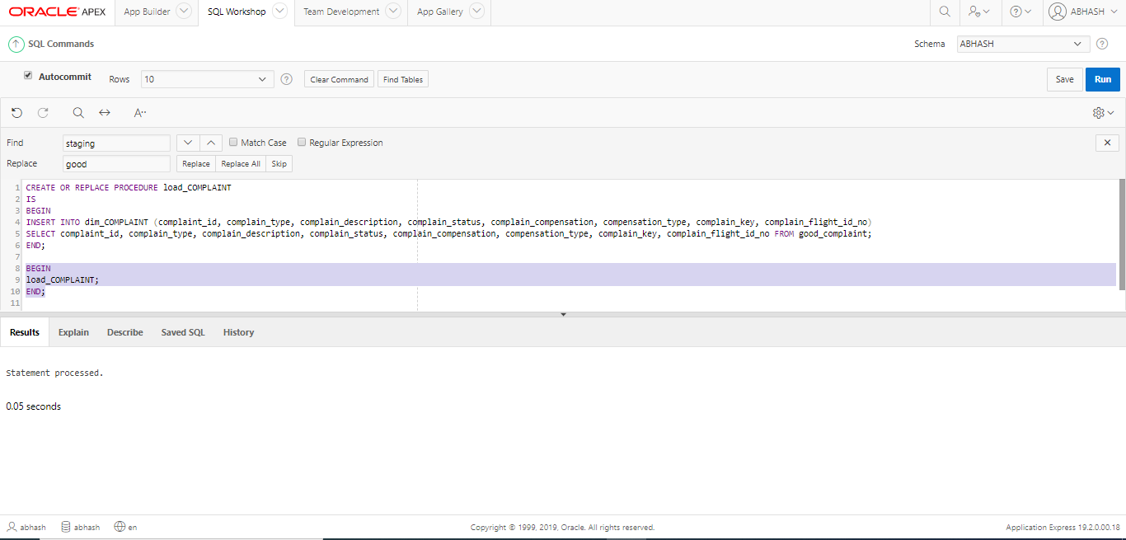

**Above screenshot shows Running the procedure**

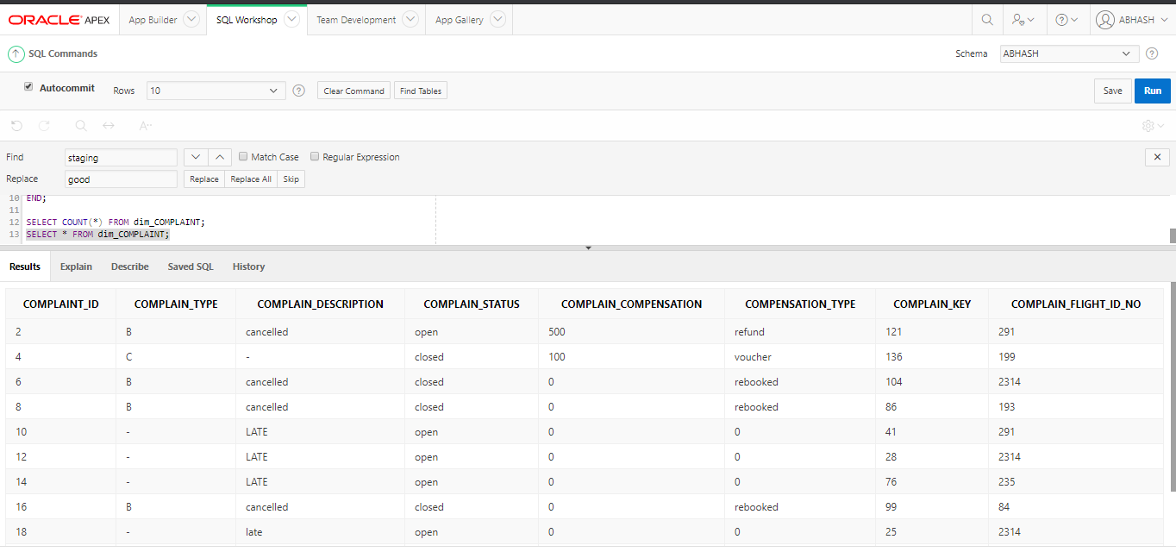

**Above screenshot shows Viewing the loaded data from dim_complaint**

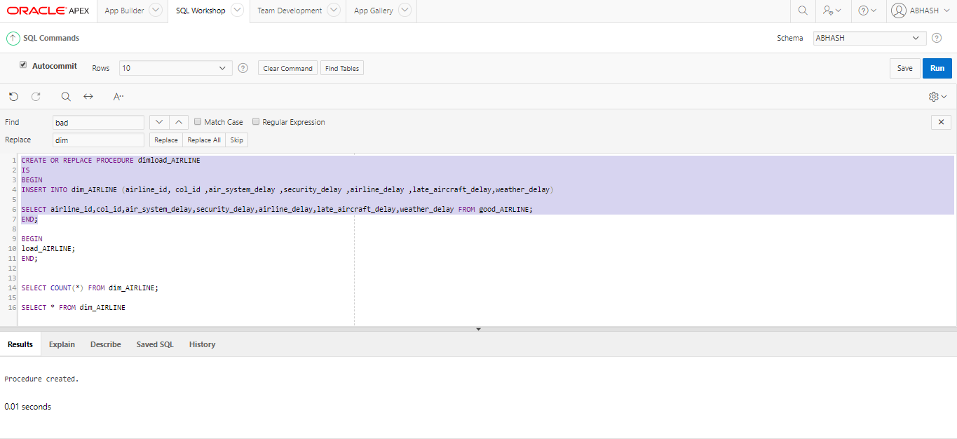

**Above screenshot shows Creating procedure for loading good_airline data into dim_airline**

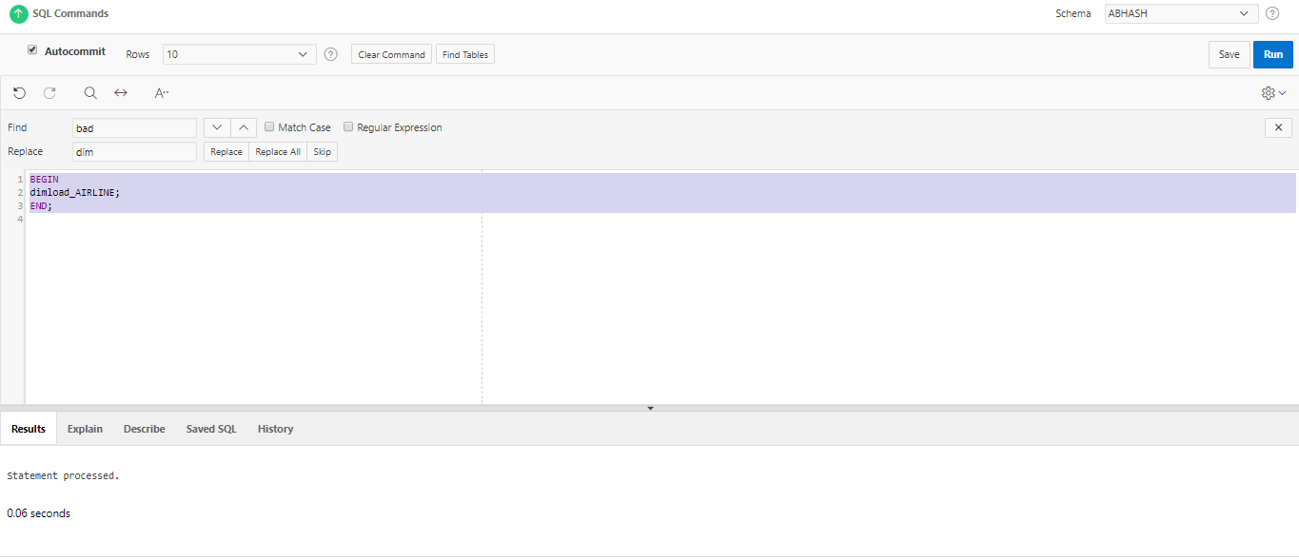

**Above screenshot shows Running the procedure**

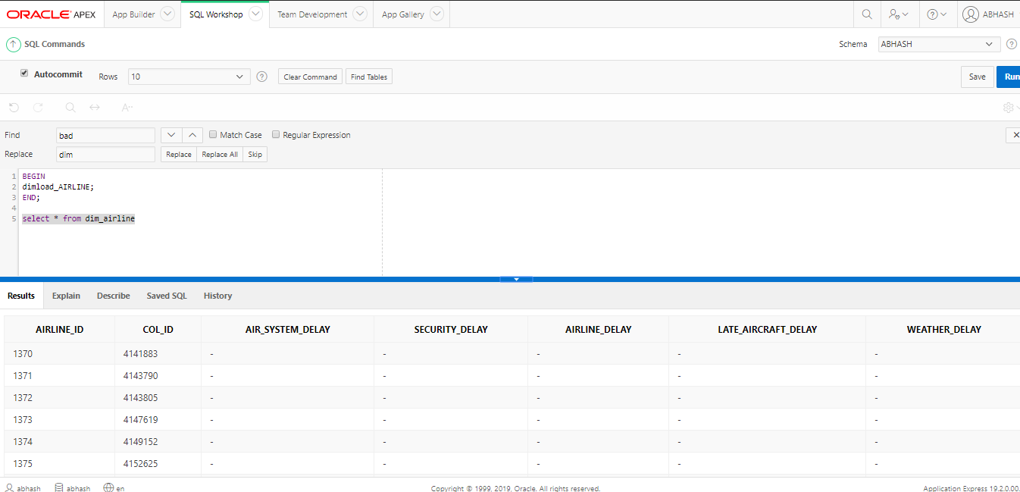

**Above screenshot shows Viewing loaded data in dim_airline**

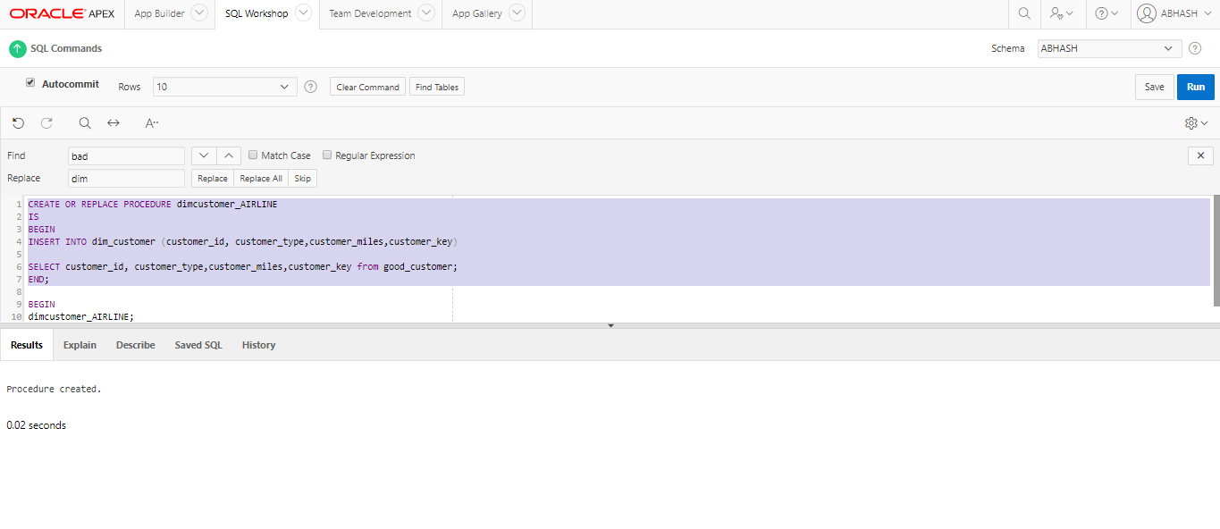

**Above screenshot shows Creating procedure for loading good_customer data into dim_customer**

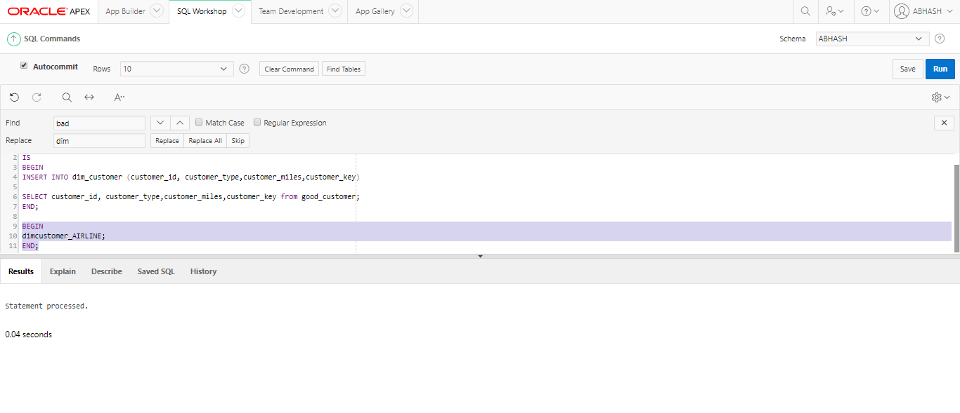

**Above screenshot shows Running created procedure**

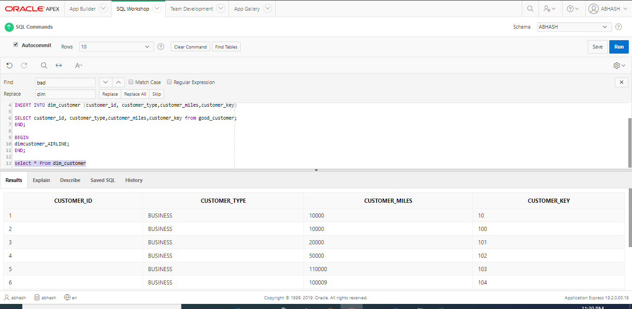

**Above screenshot shows Viewing loaded data table dim_customer**

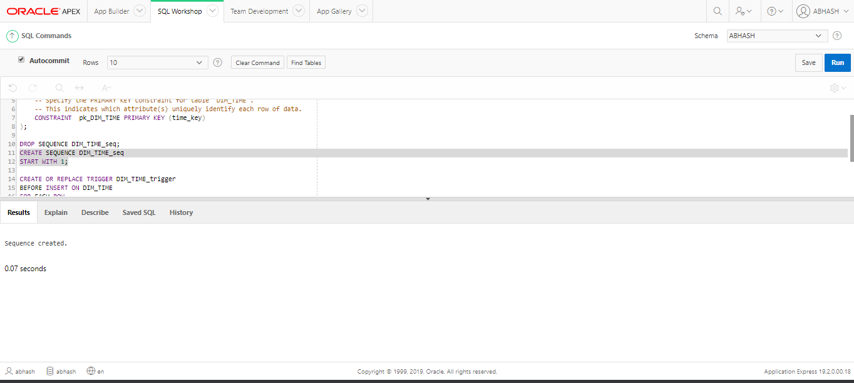

**Above screenshot shows Creating sequence for dim table ‘dim_time’**

**Creating trigger for dim_time table**



**Above screenshot shows Inserting data year,month into dim_time from flyu_flights**

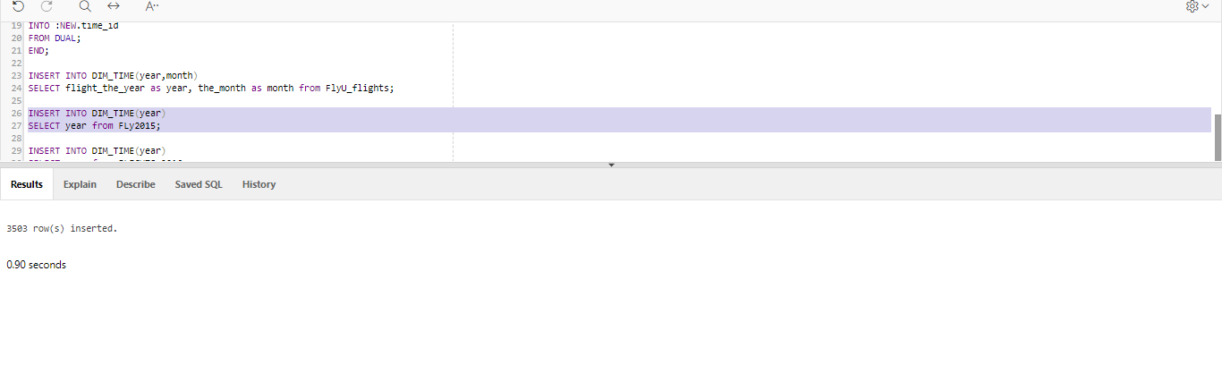

**Above screenshot shows Inserting data year into dim_time from fly2015**

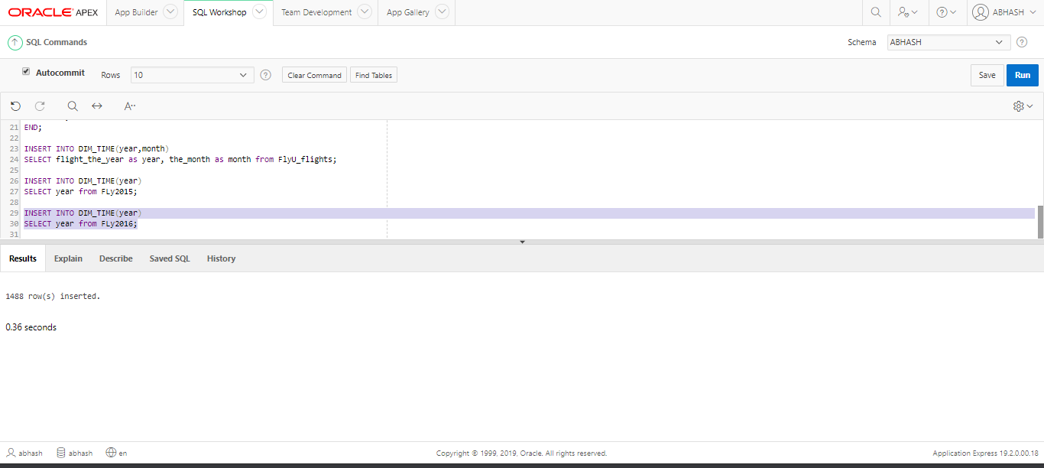

**Above screenshot shows Inserting data year into dim_time from fly2016**

## Fact table

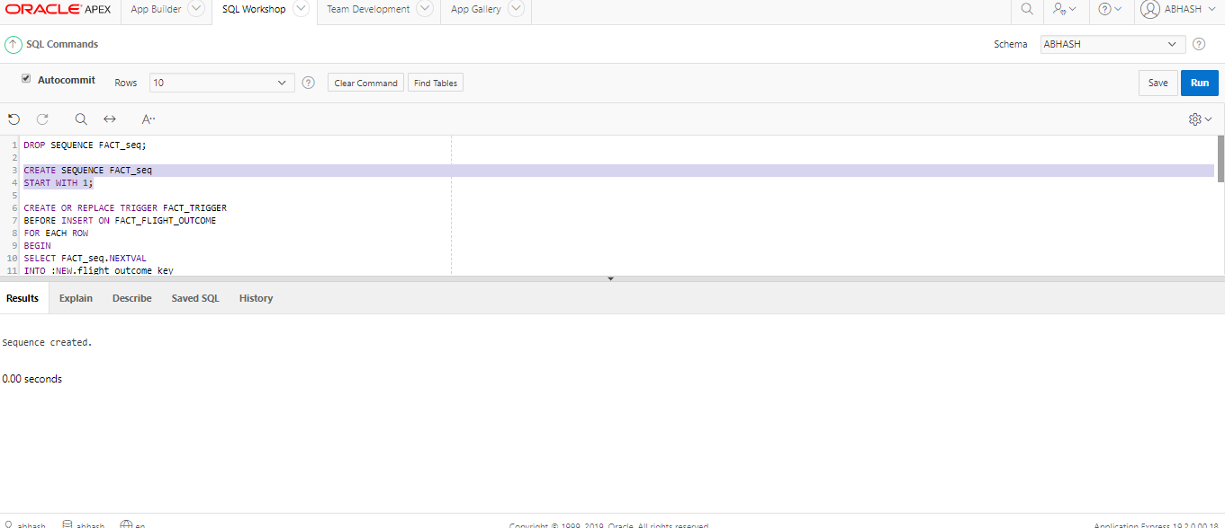

**Above screenshot shows Creating sequence for fact table**

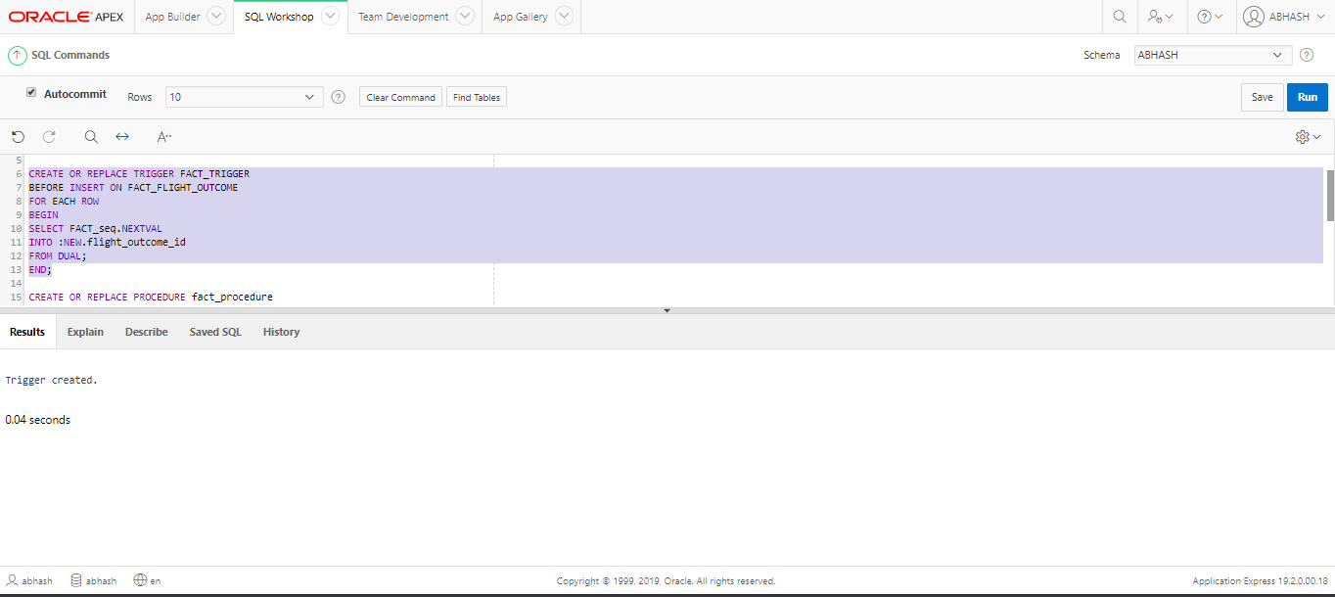

**Above screenshot shows Creating trigger for fact_flight_outcome**

## **Task 2: Data Analysis/OLAP/Mining Investigation**

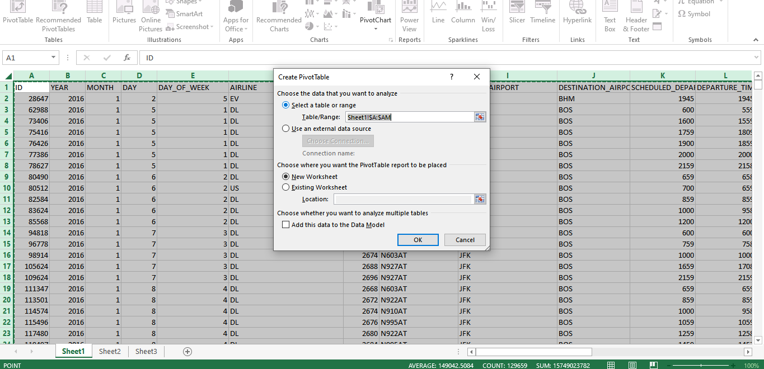

**Above screenshot shows Creating pivot table for data**

## Excel Reports

**Below screenshot shows Total number of cancel flight**

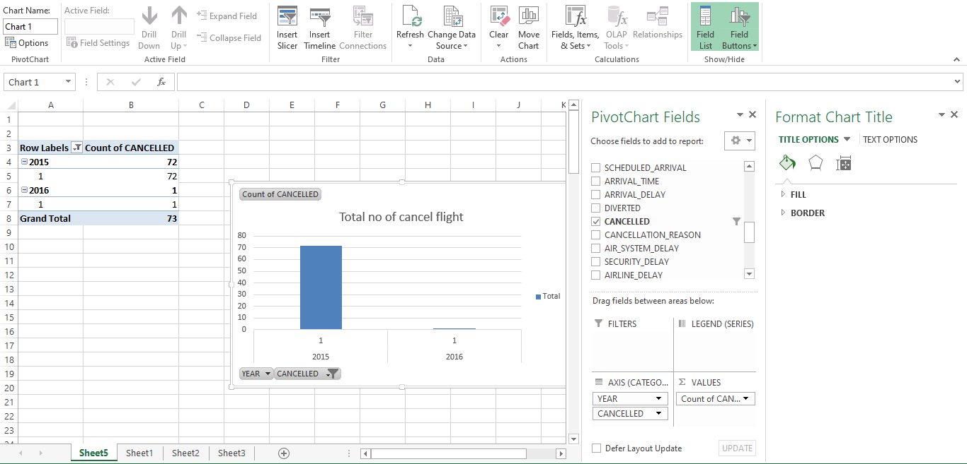

**Belows screenshot shows Total No of flight diverted**

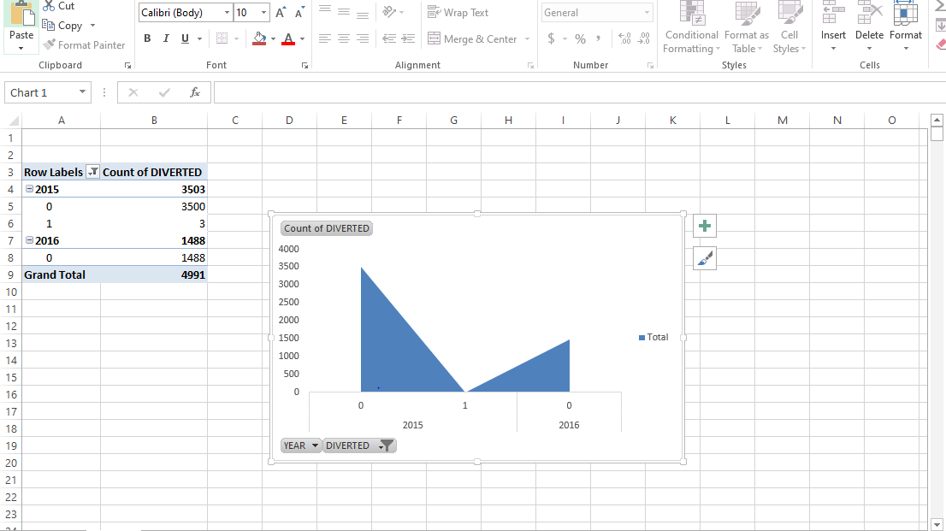

**Below screenshot shows Total number of flights each month**

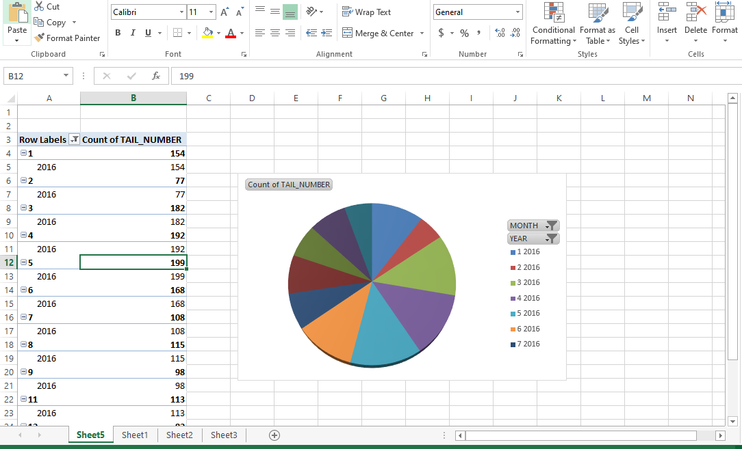

**Below screenshot shows Airline delay each month**

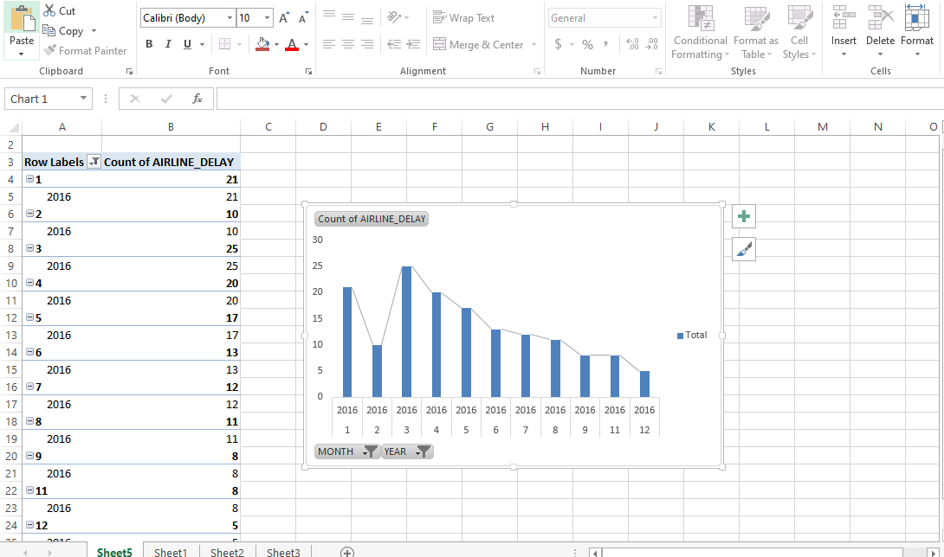

**Belows screenshot shows Count of destination airport**

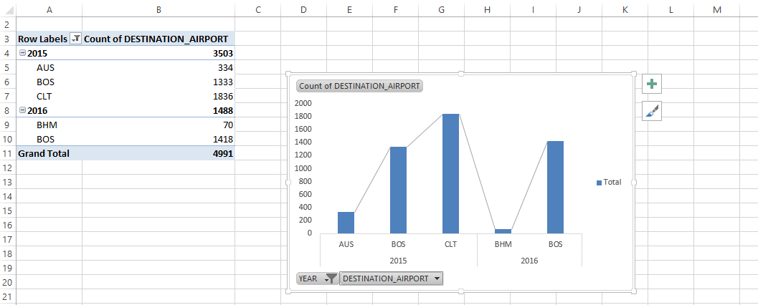

## Tableau report

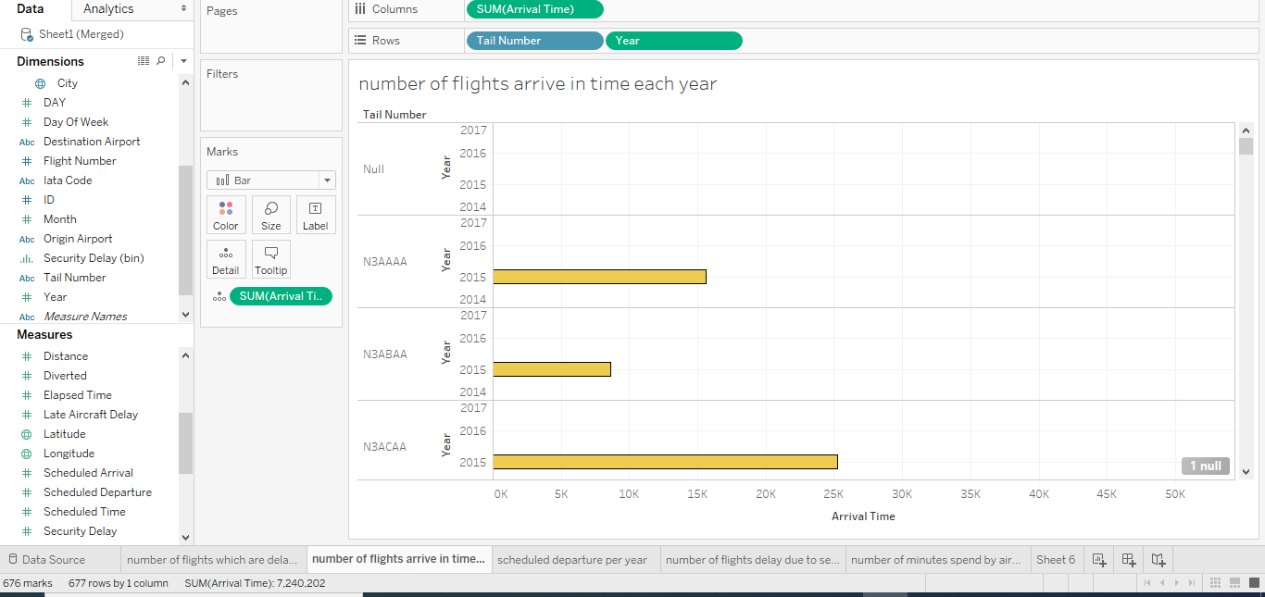

**Above screenshot shows Number of flights arrived in time per year**

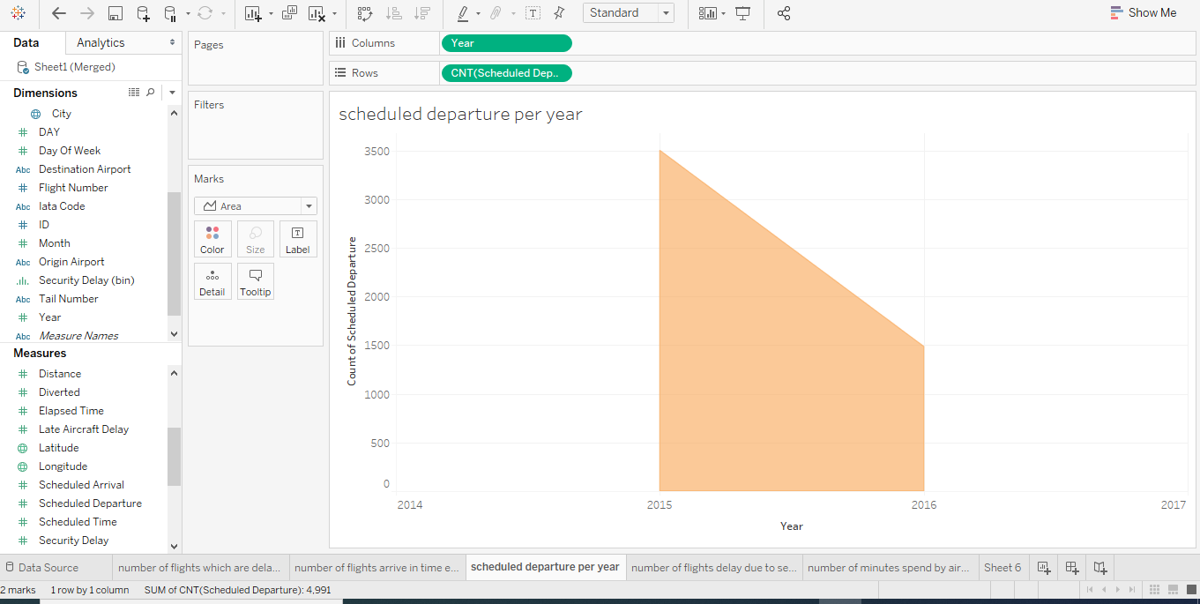

**Above screenshot shows Sum of scheduled departure per year**

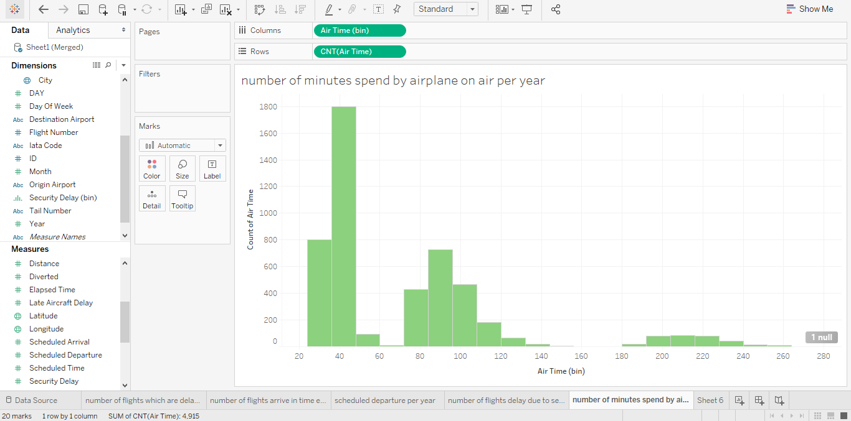

**Above screenshot shows Sum of minutes spend by airplane on air per year**

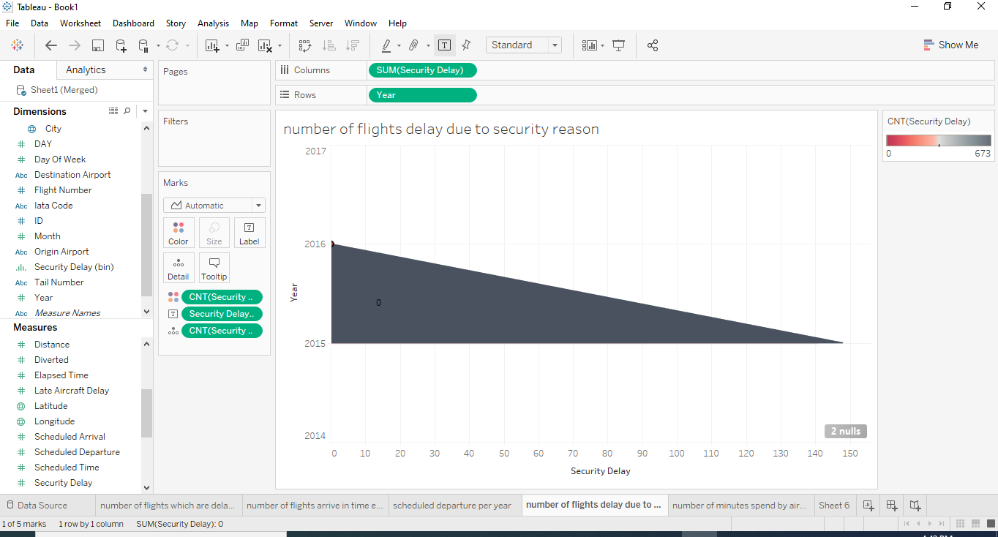

**Above screenshot shows Number of flights delay due to security reason**

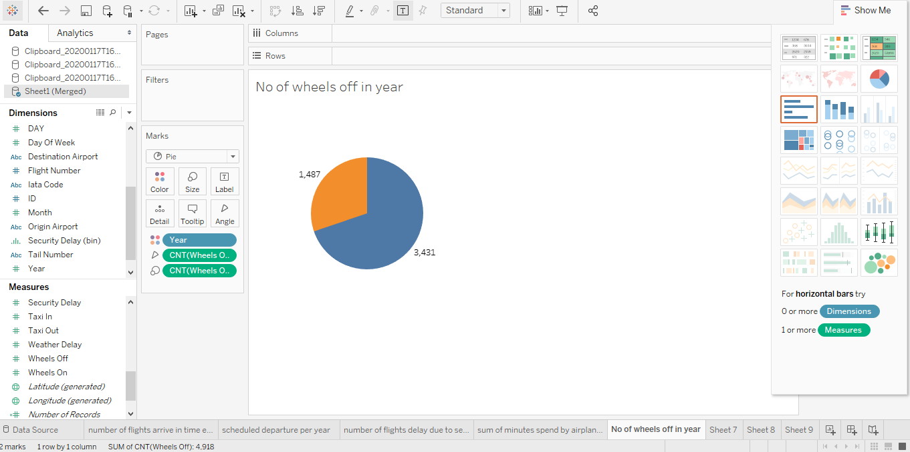

**Above screenshot shows Number of wheels off in a year**

## Apex reports

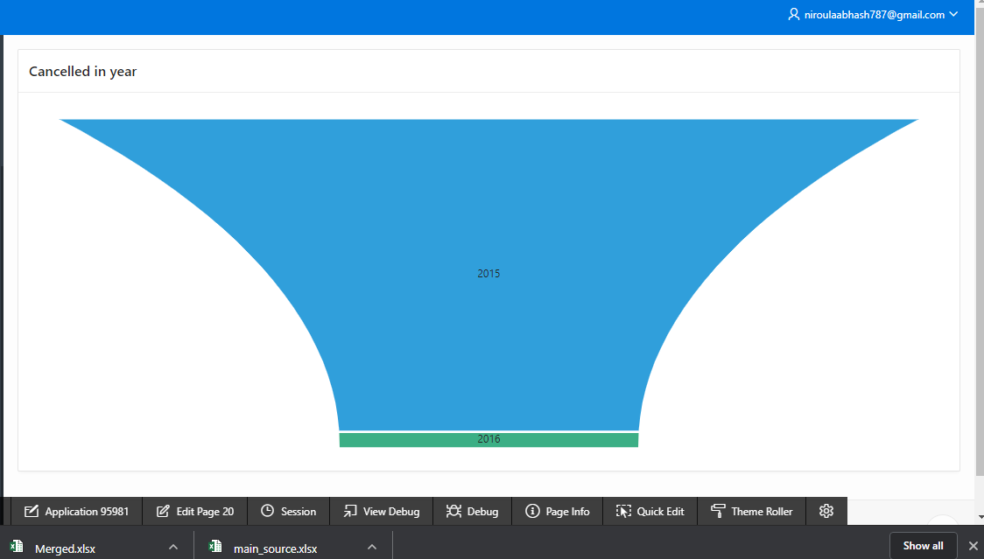

**Above screenshot shows number of cancelled flight per year**

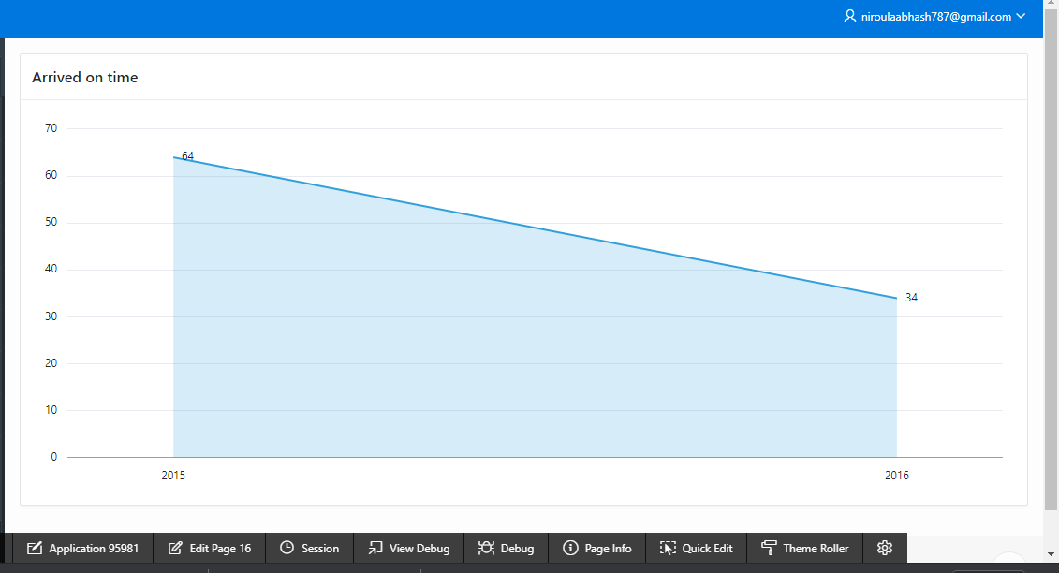

**Above screenshot shows no of flights arrived on time**

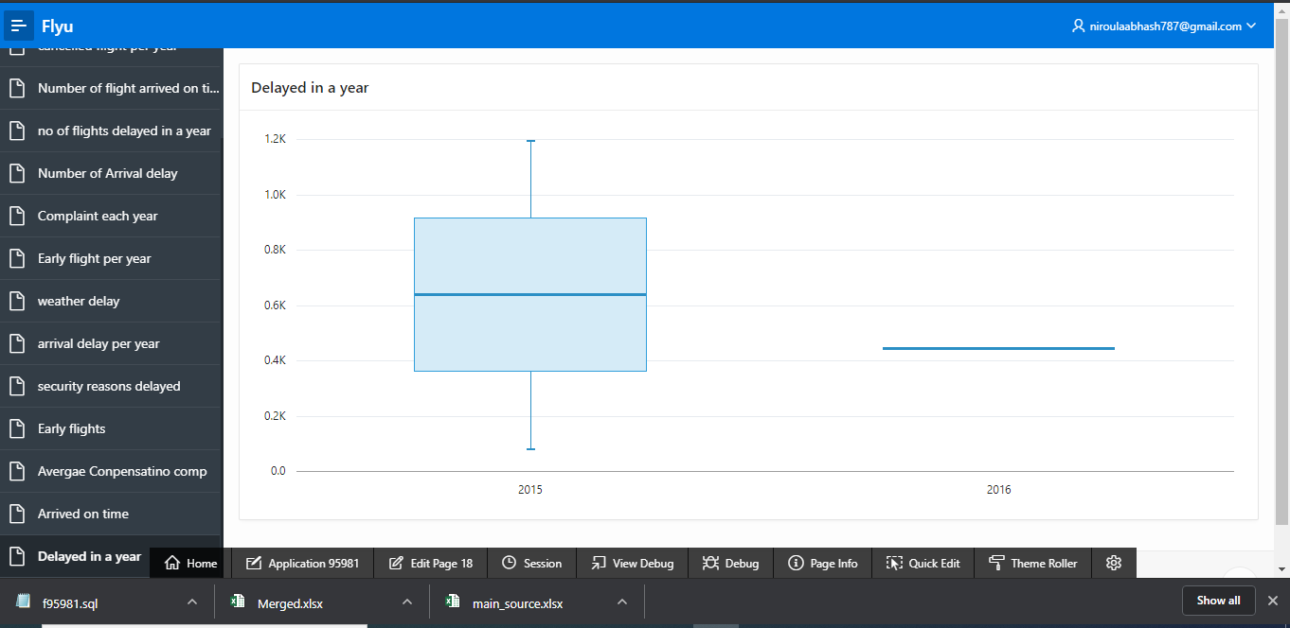

**Above screenshot shows no of delayed in a year**

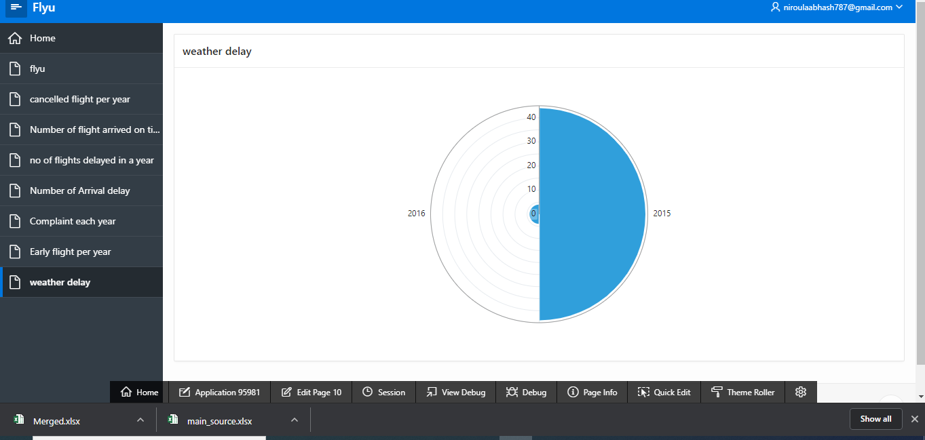

**Above screenshot shows no of weather delay in year**

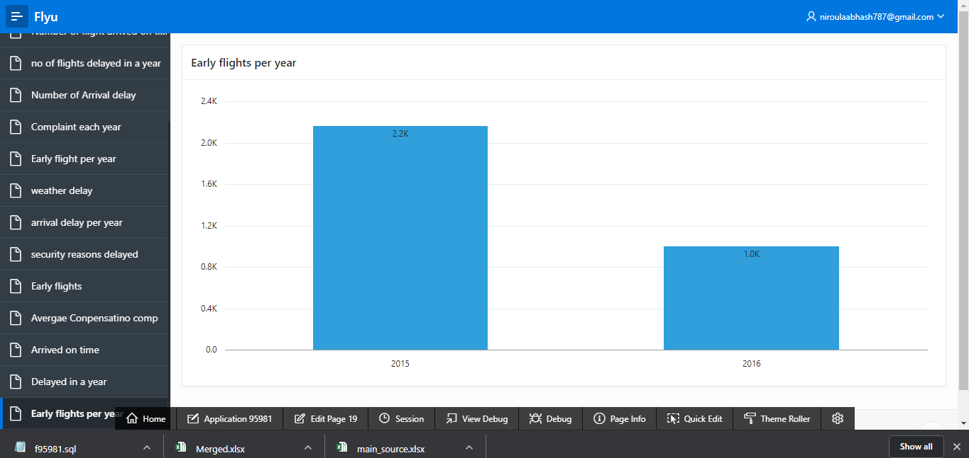

**Above screenshot shows early flights per year**

## Task 3: Considerations for the Data Mart.

# Data Maintenance

Data Maintenance is used to describe a set of tasks that are to improve the database. There are routines which are used to help the performance, check for errors in database, free up disk space, update the internal statistics and check for hardware faults. To maintain databases with large amount of data the data is divided into partitions that can be managed and accessed separately. It can also provide the mechanism for dividing the data by the usage pattern.

The partitioning of data must be done carefully to maximize the benefits of the data and to minimize the adverse effects. There are three different strategies of partitioning data.

### Horizontal Partitioning

In horizontal partitioning each partition is stored in a separate data store and all the partitions have the same schema. Each partition in horizontal partitioning is known as a shard and hold the specific subset of the data such as specific set of customers.

The most important factor in horizontal data partitioning is the choice of sharding key. Choosing a sharding key should minimize any future requirements to split large shards, coalesce small shards into larger partitions or change the schema. If the shards are replicated, it might be possible to keep some of the replicas online while others are split, merged or reconfigured.

### Vertical Partitioning

Vertical Partitioning is used to reduce the performance costs associated with fetching items that are accessed frequently. Vertical partitioning operates at the entity level with the data store, partially normalizing an entity to break it down from a wide item to a set of narrow items.

Vertical partitioning can be used to separate relatively slow-moving data from dynamic data. Vertical partitioning can be used to store sensitive data with security controls and is used to reduce the amount of concurrent access.

### Functional Partitioning

Functional partitioning is used to improve isolation and data access performance when it is possible to identify a bounded context for each distinct business area in an application. Functional partitioning is also used to separate read write data from read only data. The functional partitioning strategy can help reduce the data access contention across different parts of a system.

### Slow Changing Dimension (SCD)

A Slowly Changing Dimension (SCD) is a dimension that stores and manages both current and historical data over time in a data warehouse. It is considered and implemented as one of the most critical ETL task in the full history of dimension table record. Implementing the SCD types should enable users assigning proper dimension’s attribute value for given date. The major approaches of Slow Changing Dimension (SCD) are:

### Type 0

Type 0 is the passive method of SCD. In this method no special action is performed on the dimensional changes. Some dimension data can remain the same as it was before and some data may be overwritten.

### Type 1

In Type 1 method no history of dimension changes is kept in the database. The old dimension value is overwritten by the new one. Type 1 is easy to maintain and is often used for data which changes by processing corrections like removal of special characters or spelling errors.

### Type 2

In Type 2 all history of dimension changes is kept in the database. We capture the attribute change by adding a new row with a new surrogate key to the dimension table. Both the previous and new rows contain as attributes. Changing the dimensional model in Type 2 is very expensive for the overall database operation so it is not recommended to be used in dimensions where new attributes could be added.

### Type 3

In Type 3 the current and previous value of dimension is kept in the database. The new value is loaded into new column and the old one is loaded into the old column. The history is limited to the number of columns created for storing historical data.

### Type 4

In Type 4 method a separate historical table is used to track all the dimension’s attribute historical changes for each of the dimension. The main dimension table keeps only the current data.

### Type 6

In Type 6 method to capture the attribute change we add a new record in Type 2 method. The information is overwritten with new one das in Type 1 method.